Winthrop John Lapeyrolerie
October 20, 1932 – June 30, 2010

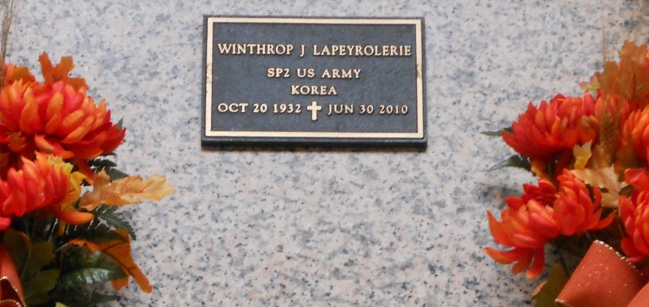
Photo by Team T-Lo

Winthrop "Wimpy" John Lapeyrolerie on Wednesday, June 30, 2010 at his home in Reserve, LA.
Son of Marguerite D. Lapeyrolerie and the late Francois Lapeyrolerie. Husband of Dionne H. Lapeyrolerie. Father of Wendel, Jeffrey, Kenneth, Roderick, Jennifer, Lynette, Renee and Brian Lapeyrolerie. Brother of the late Frank and Raymond Lapeyrolerie. Father-in-law of Myra and Nicole Lapeyrolerie. Also survived by 11 grandchildren and a host of nieces, nephews, other relatives and friends. Age 77 years. A native and resident of Reserve, LA.
Relatives and friends of the family, also priest and parishioners of Our Lady of Grace Catholic Church and all neighboring churches are invited to attend the Mass of Christian Burial at Our Lady of Grace Catholic Church, 772 Highway 44, Reserve, LA on Saturday, July 3, 2010 at 11:00 AM. Father Joseph Rodney, Celebrant. Interment St. Peter Cemetery, Reserve, LA. Visitation at the above named church from 9:00 AM until Mass time.
In lieu of flowers, a donation can be made to Xavier University Alumni, New Orleans, Louisiana Class of 1954. SERVICE BY ROBOTTOM.

Times Picayune, New Orleans, Louisiana
July 2, 2010

