Adam Lasseigne
August 20, 1813 – November 25, 1906

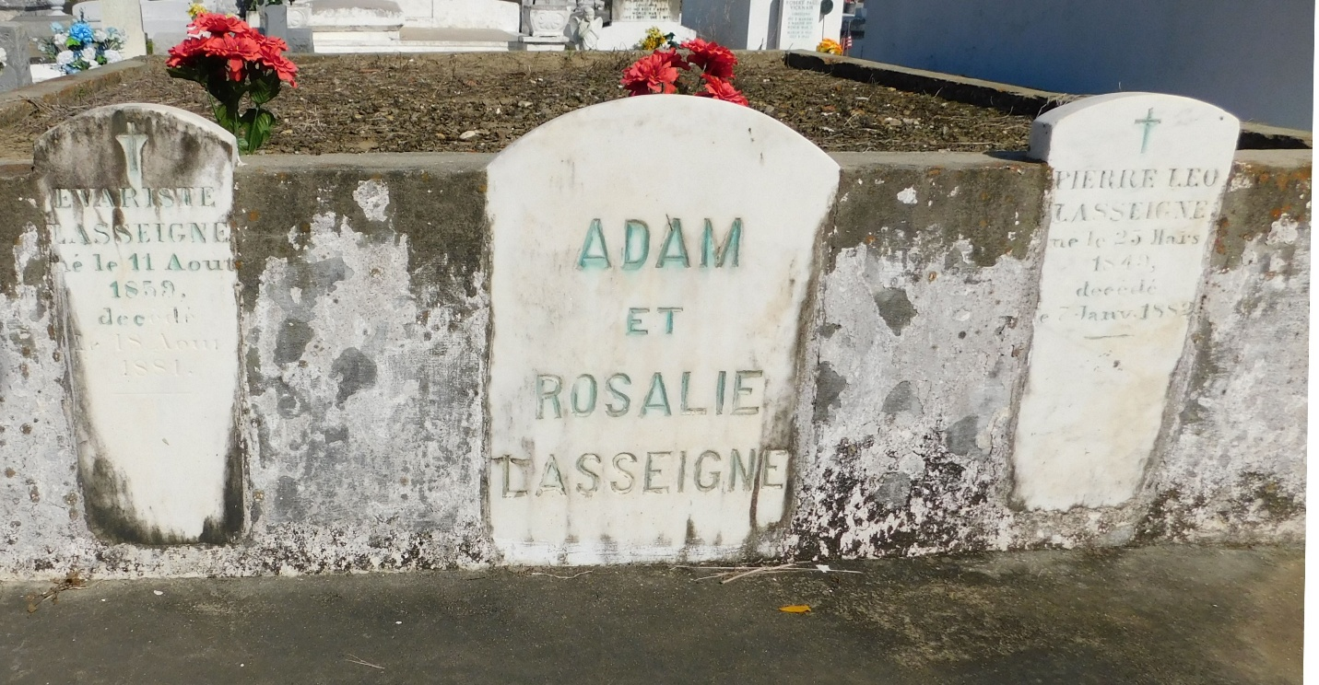
Photo by Mary Agnes Hammett

Adam Lasseigne died Sunday, 25 Nov 1906, on the left bank of the river at an age of 93 years and 3 months. He had been ill for about a month. Interment was in St Peter Cemetery.
Le Meschacébé, Louisiana
1 Dec 1906, p. 1

