Augustin Lasseigne
February 5, 1862 – November 28, 1925

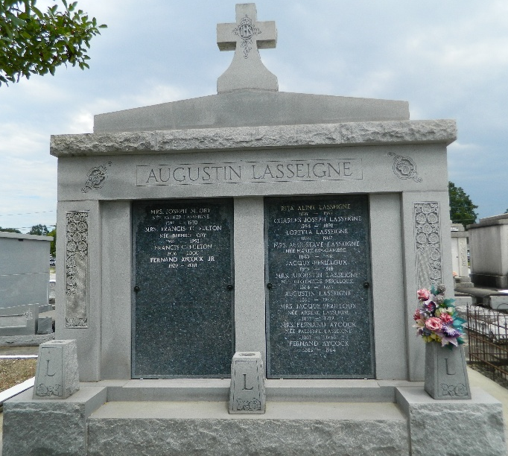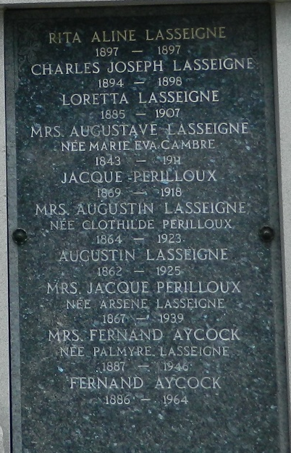

Death, the inevitable death, which respects nothing and which comes when we least expect it, has again passed its merciless scythe among us and chose for its victim this time one of our best citizens, a man whom everyone looked upon more as a true guiding father than a mere friend. In the death of Mr. Augustin Lasseigne, of Laplace, LA, which occurred last Saturday morning at 10:30 o'clock, at Hotel Dieu, in New Orleans, after an illness of a few weeks duration, the Parish of St John has lost one of her most honored sons, his friends, one of their loyal supporter and adviser, his children, a dutiful and true loving father.
Loule, as he was familiarly known, was a self-made man who acquired a considerable fortune by his energy, thrift and good business acumen, still his simplicity of manners, benevolence and kindness toward all, poor and rich alike, no stranger would have taken him to be a rich man and he won the friendship and love of all who come in contact with him by his unlimited acts of charity and was deservedly popular. From a boy he had adopted for his motto the word "honesty" and all his transactions were carried under that principle which endeared the people to him, they trusted him because they knew he was good, honest, fair and square, together with his simplicity of manners, his sincerity and kindness and his remarkable practical business ability may be said to have been his dominant characteristics.
When quite a young man he formed a partnership with Mr. Leonce Keller, now of Hester, LA, which proved very successful and which was Mr. Lasseigne's real start in life. After dissolving partnership with Mr. Keller in 1898, he formed a co-partnership with MM. John, Lezin and Emydge Ory, and together they bought Woodland Plantation at Laplace, which remained their property until last year when the plantation was cut up in small farms and sold. Besides being a part owner of Woodland Plantation and Woodland Store, he was part owner of the San Francis Plantation and Lasseigne-Englade Store at Lions, the Cedar Grave Plantation in Iberia Parish and Ellington Plantation in St Charles Parish.
Mr. Lasseigne was born in this Parish 64 years ago, and always lived the Parish; before moving to Laplace in 1898 he resided at Lions. He always took an active part in the business, civic and political life of St John, having served as president of the Police Jury for a number of years, and it was during that time the Parish really felt his worth, for on many occasions he made big loans to the Parish. He was president of the Bank of St. John at the time of his death. He always took a leading part in the upbuilding of his parish. Being an organizer and active member of St Peter's Council No 2436, Knights of Columbus, and John A Reine Camp No 504, Woodman of the World, and was always a leader in all church activities, being instrumental in securing the St Joan of Arc Chapel in Laplace. No one can tell to what extent he alleviated the poor in their suffering by his charity, his heart being always larger than his purse.
Deceased, who was preceded to the tomb two years ago by his wife, is survived by one son, Geo. A. Lasseigne of Laplace, two daughters, Mrs. Fernand Aycock of Honduras, and Mrs. Joseph M Ory of Lions, several grand-children and one sister, Mrs. Jacques Perilloux of Laplace.
L'Observateur, LaPlace, Louisiana
Undated clipping
Contributed by Dwayne Montz

