Beatrice (Vicknair) Lasseigne
February 15, 1911 – May 9, 2006

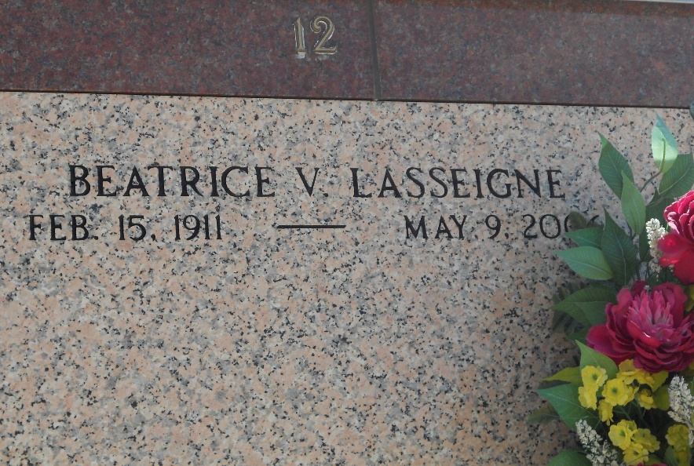
Photo by Team T-Lo

Beatrice Vicknair Lasseigne, on Tuesday, May 9, 2006 at 6:00 P.M.

Beloved wife of the late Leo Lasseigne. Daughter of the late Amelues and Eusela Vicknair. Sister of the late Francis Vicknair, Thelma Bourg, Edna Mae Montz and Hilda Labat. Also survived by nieces and nephews. Age 95. A native and a resident of Reserve.

Relatives and friends of the family, also members of the Ladies Altar Society and American Legion Auxiliary are invited to attend services. Visitation at St. Peter Catholic Church, Reserve on Friday, May 12, 2006 from 8:00 A.M. until 10:00 A.M. Followed by religious services in the church at 10:00 A.M. Burial in church cemetery. Arrangements by MILLET-GUIDRY FUNERAL HOME, LaPlace.
The Times-Picayune, New Orleans, Louisiana
11 May 2006

