Charles Adrien Lasseigne Sr.
June 1, 1842 – February 7, 1913

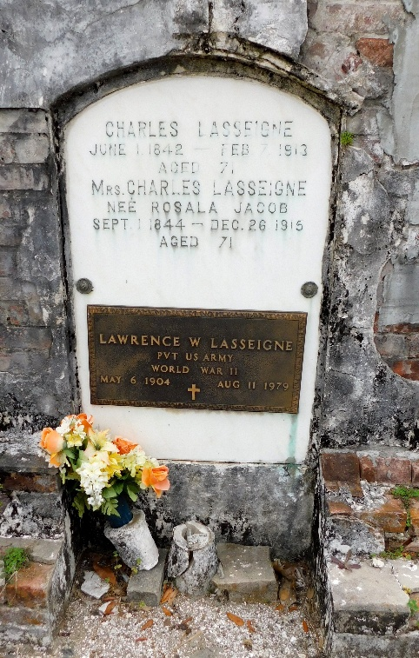
Photo by Mary Agnes Hammett

Our Stories, Our History: Journalism push starts in 1852
By Ronny Michel

LAPLACE — As the steamer Mary Foley docked in Lucy in 1852, few onlookers may have realized it carried the seed for journalism in St. John the Baptist Parish. The equipment was ordered by Hypolite Prudent deBautte, who wrote under pen name Prudent d'Artly, and was used to publish the newspapers Le Meschacébé (meaning Big River in the Indian language) and L'Avant Coureur (French for forerunner) in St. John the Baptist and St. Charles parishes, respectively. The first issues were published Jan. 23, 1853. Written mostly in French, the papers were sold five years later to Eugene Dumez and Ernest LeGendre. "In 1857, L'Amerique, a French and English newspaper, was published in Reserve," said local historian Gerald Keller. "The little paper was put out for two or three years by Maurice Edrington and then discontinued." The editors of Le Meschacébé were not without controversy, for the April 3, 1858, issue of Le Meschacébé reported, "On the occasion of an article in the last issue of Le Meschacébé, a challenge was presented to Mr. E. LeGendre in the name of Gustave Furrate. The challenge was accepted and his bond was met. The adversaries fought with swords. Mr. LeGendre received a slight wound to the upper part of his chest. The seconds stopped the combat."
By 1860, two other newspapers were in the parish — LeJeune Americaine and La Ruche Louisianaise. The latter was a weekly newspaper published by Charles A. Lasseigne. LeGendre left the business after a few months, and Dumez became the sole editor of Le Meschacébé. Publication was suspended near the end of 1862, during the Civil War, and resumed in 1865 after the war ended. Dumez died in 1878. In January 1879, Lasseigne and Lovincy Montz acquired the paper and moved it to Reserve, but Lasseigne eventually became the sole owner.
"Materials in the Le Meschacébé were taken largely from magazines and other papers and editorials always ignored local news," said Keller. Although his son Wallace Lasseigne worked for him after studying journalism in Ruston, when Charles' eyesight began to fail in 1909, he did not hand the paper to Wallace. "He didn't think that my grandfather would make anything out of the paper so he sold it," Gloria Triche, the 83-year-old granddaughter of Wallace, said in a recent interview. Eugene Dumez Jr. bought the paper, discontinued the French language, and moved it back across the river to Edgard. Four years later, he sold it to John Reynaud, who published it until 1942.
Wallace never gave up his desire for journalism and sought a way to publish the local issues of the day. In 1913, using fonts salvaged from his father's shop, Wallace hand-set and hand-cranked the first issue of L'OBSERVATEUR, printed in half-French and half-English, clearly stating the purpose of the paper. "In presenting L'Observateur to the public, we present an up-to-date, clean, free and independent newspaper, a newspaper which will not be controlled by any 'clique or ring,' but will defend the interest of the people within its power." Some occasionally took issue with what he printed. "He was thrown in jail a couple of times," Triche laughed. "But he always got out." Triche fondly remembers the many days she spent in the office of L'OBSERVATEUR, which was located near the intersection of River Road and East 22nd in Reserve. "I grew up in that office," Triche said. "I remember that during the winter months, my grandfather's hands were dry and cut from setting the type. He would coat them with Vaseline." The purchase of a Linotype machine in 1940 did away with the job of typesetting. "My Uncle Bob was the one who learned how to use the Linotype, but he worked at another job during the day and would work at the paper at night," Triche said. "He eventually taught my mom to run it, and she worked at the paper for over 30 years."
Wallace had every intention of turning the paper over to his son, Larry, who studied journalism at LSU and was sports editor of the Reveille. Larry entered the infantry and was sent overseas on his 19th birthday, Aug. 17, 1944. He served in England, France and Germany, and was reported as missing in Germany. "My grandfather was devastated," Triche remembers. "He wrote to the War Department and kept hoping that his son would be found." Wallace received the devastating news through a letter on March 27, 1946, that his son had been killed on March 5, 1945.
L'OBSERVATEUR was sold to Joseph Lucia, Milton Landry and Arthur Louque in 1949 and began to be printed in English only. It was moved to LaPlace in 1959 and occupied half of the building presently owned by Destiny Christian Center. By 1967, offset printing had replaced the Linotype. Lucia eventually became the sole owner and in 1974 moved the paper to its present location at 116 Newspaper Drive in LaPlace. Lucia's son, Joseph "Tardy" Lucia Jr. bought the paper in 1977 and later sold to Wick Communications in 1985. The paper was sold again in 2014 and is run by LaPlace Newsmedia, which is owned by Carpenter Newsmedia, an affiliate of Boone Newspapers. Wallace would undoubtedly be pleased with the continued publication of the newspaper he began, for he penned these words upon his retirement in 1949: "It gives me great pleasure to know that the paper I founded in 1913 has continued until now and shall remain in operation." Triche agrees. "I've had a L'OBSERVATEUR in my home every day for almost 84 years," she said as she wept gently. "It's a part of my heart."

L'Observateur, LaPlace, Louisiana
August 27, 2016

