Clothilde (Perilloux) Lasseigne
October 4, 1862 – October 26, 1923

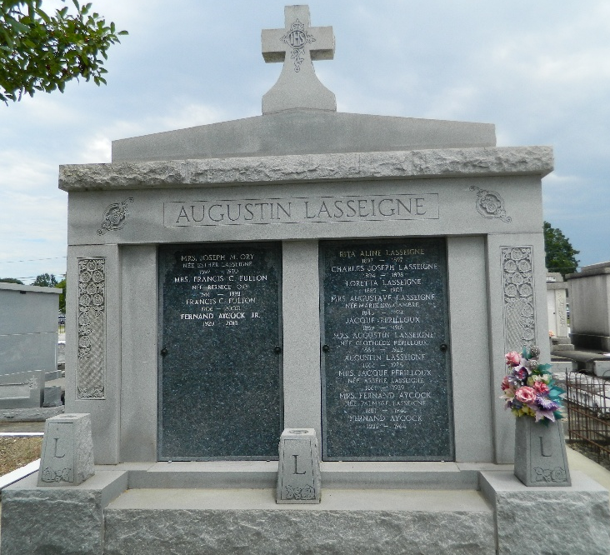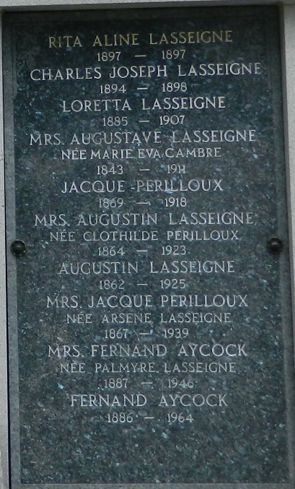

Mrs. Augustin Lasseigne, nee Clothilde Perilloux, died at her home in Laplace, LA, last night.

Interment St Peter Cemetery the next day.

Survived by 3 children, Mrs. F J Aycock of Honduras, Mrs. J M Ory of Lions, and George A Lasseigne of Laplace.

L'Observateur, LaPlace, Louisiana
October 27, 1923

