Marie Eve (Cambre) Lasseigne
January 12, 1844 – August 6, 1911

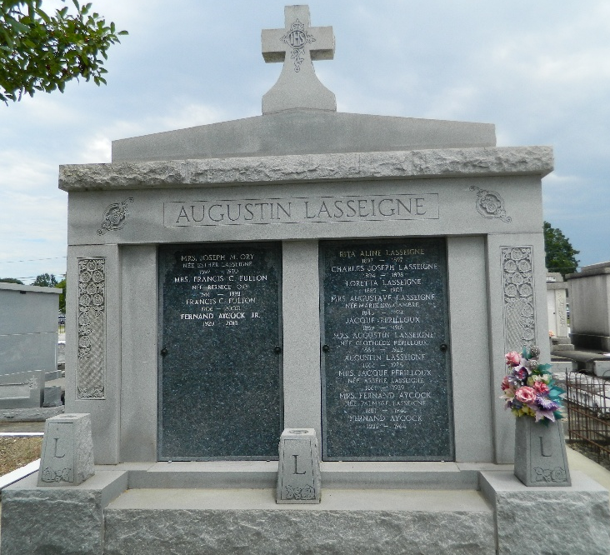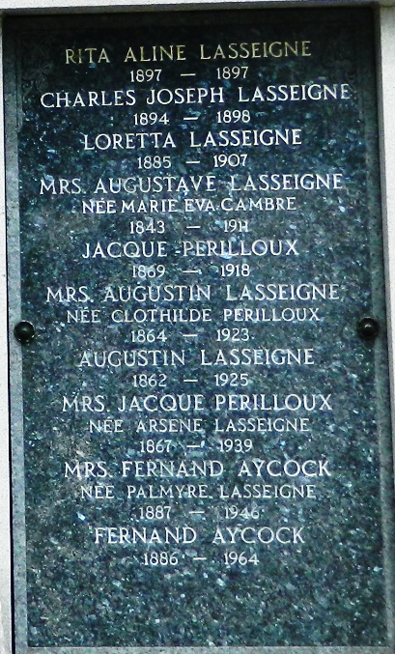

Death of Estimable Lady.
It is with deep regret that we chronicle the death of Mrs. Augustin Lasseigne, who passed away at LaPlace on Sunday morning, at the age of 67 years. Mrs. Lasseigne was one of the community's noblest and best-beloved women. Although in failing health for some time, she accepted her sufferings patiently and without complaint.
Mrs. Lasseigne, nee Miss Marie Cambre was the daughter of Mathias Cambre and Arsene Rodrigue led a quiet and homely life and was a devoted mother. She was the mother of Augustin and Albert Lasseigne, the former being favorably and widely known as the president of the Bank of St John, and president of the Police Jury of this parish, and of Mrs. Jacques Perilloux.
By ties of birth and marriage, deceased was connected with some of the oldest and most prominent families in St John. To her children, she was a partner in the joys and sorrows of their childhood days, in the hopes and aspirations for the future, at all times a loving and tender mother, ever ready with kind counsel to soothe their sorrows and extoll their virtues.
Mrs. Lasseigne was living with her son, Mr. Augustin Lasseigne, when claimed by the angel of Death. After services at St Peter's Catholic Church on Monday, her remains were borne to the cemetery and laid to rest, the pall-bearers being Olidee Cambre, Louis Cambre, Albert Lasseigne, Jacques Perilloux, Edwin Cambre and Louis Bredy.

Le Meschacebe, St. John the Baptist Parish, Louisiana
August 12, 1911

