Regina (Petrolia) Lasseigne
January 27, 1923 – May 15, 2003

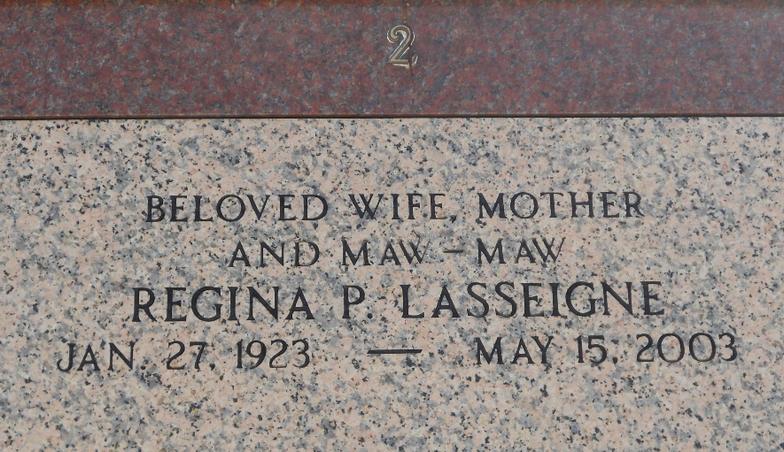
Photo by Team T-Lo

Lasseigne - Regina Petrolia Lasseigne On Thursday, May 15, 2003 At 9:44pm.
Beloved Wife Of The Late James A. Lasseigne Sr. Mother Of James A. Lasseigne Jr., Ferrell J. 'Frenchie' Lasseigne, Magda L. Songy Of Reserve And Janet L. Modglin Of Houston Tx. Daughter Of The Late Tony And Regina Schnexnayder Petrolia. Sister Of Maggie St. Pierre And The Late Tony Jr., Sam And Paul Petrolia. Also Survived By 12 Grandchildren And 19 Great-Grandchildren.
Age 80 Years. A Native Of Laplace La And A Resident Of Reserve La For The Past 61 Years.
Relatives And Friends Of The Family Are Invited To Attend Services.
Visitation At Millet-Guidry Funeral Home, 2806 W. Airline Hwy., Laplace La. On Saturday, May 17, 2003 From 9am To 11:45am, Followed By Religious Services At St. Peter Catholic Church, Reserve, La At 12pm. Burial In St. Peter Church Cemetery, Reserve, La.

Times Picayune, New Orleans, Louisiana
May 17, 2003

