Kenneth Stephen Laurent
September 2, 1927 – April 2, 2004

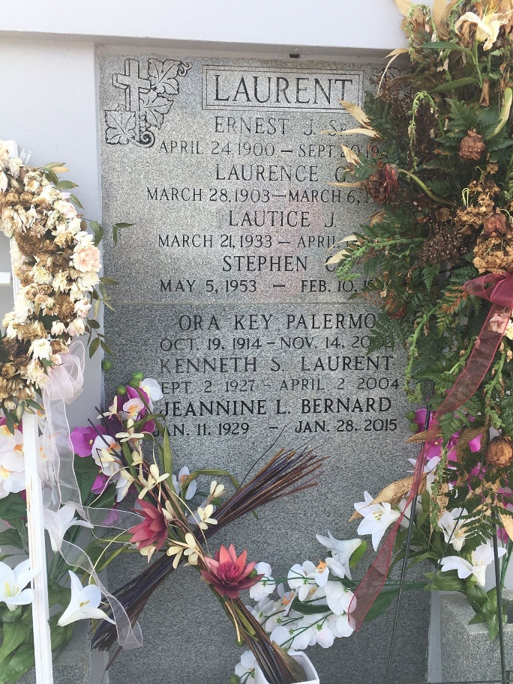
Photo by Team T-Lo

Kenneth S. Laurent On Friday, April 2, 2004 At 2:30 A.M. Beloved Husband By 1st Marriage Of The Late Lautice Jones Laurent And By 2nd Marriage Of The Late Margaret Weber Catoire Laurent. Father And Father-In-Law Of Anna And Dennis Taylor, David M. Laurent, Paul N. Laurent, Susan And Chris Pierce And The Late Stephen C. Laurent. Grandfather Of Anastacia Vath, Lautice Taylor, Samantha And Jackie Pierce And Miranda And Naomi Ora Laurent. Son Of The Late Ernest And Laurence Laurent. Brother And Brother-In Law Of Jeanine Bernard, Phyllis And Rudolph (Bubby) Begault, Anna Mae And Byron Landry And The Late Ernest Laurent, Jr. Stepfather And Stepfather-In-Law Of Darrell And Deborah Catoire, Jan And Donald Ladner And Patti And David Snyder. Stepgrandfather Of Brandi And Jeremy Catoire, Ashley, Brittany And Joshua Ladner And Devin And Courtney Snyder.
Age 76. A Native Of Destrehan, La And A Resident Of Reserve, La For The Past 40 Years.
Relatives And Friends Of The Family Are Invited To Attend Services. Visitation At St. Peter Catholic Church, Reserve, La On Monday, April 5, 2004 From 8:00 A.M. - 10:00 A.M. Followed By Religious Services At The Church At 10:00 A.M. Burial In Church Cemetery. In Lieu Of Flowers, Masses Or Donations To The Monsignor Eyraud Fund, C/O St. Peter Catholic Church, Reserve, La. Preferred. Arrangements By Millet-Guidry Funeral Home, Laplace, La.
Times Picayune, New Orleans, Louisiana
April 3, 2004

