Lorrie (Montz) Laurent
July 1, 1927 - August 9, 2018

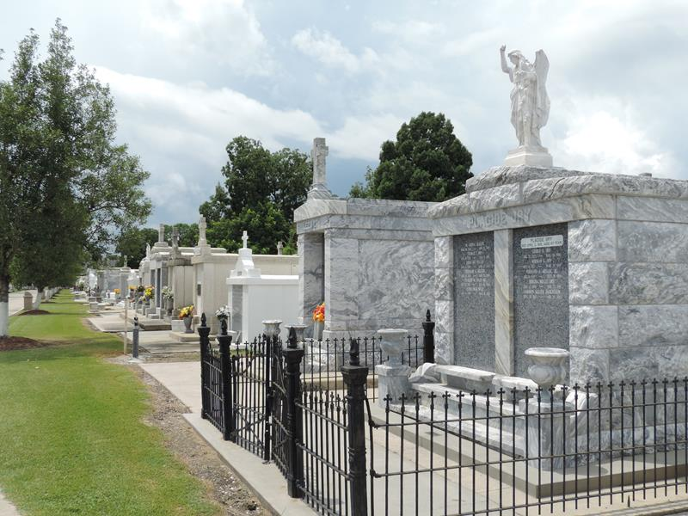

On Thursday, August 9, 2018, Lorrie Montz Laurent went to heaven to join her husband, Ewell Laurent. Lorrie was born on July 1, 1927 in Reserve, LA, the only child of Rudolph “Dutch” Montz and Vervette Catoire, who sadly died during childbirth. She was lovingly raised by Vervette’s parents, Achille and Victorine (Jacob) Catoire.
Lorrie was a loving mother, grandmother, and great-grandmother who loved to crochet and sew. She was a member of the St. Peter’s Ladies Altar Society and for many years and made the baptismal covers for the christenings. She was also a long time member of the Ladies Auxiliary of the VFW.
Left to cherish her memory are two sons and their wives, Duane & Susan Laurent and Kevin “Chin” & Merle Laurent; three grandchildren and their spouses, Sarah & Kevin Williams, Lance & Lindsey Laurent, and Lane & Morgan Laurent; and two great-grandchildren, Baylee and Mason Laurent.
Masses are preferred in lieu of flowers. A visitation in her honor will be held on Monday, August 13, 2018 at St. Peter Catholic Church in Reserve, LA from 9:00 am until 11:00 am followed by a Mass of Christian Burial and entombment in the St. Peter cemetery.

Rose Lynn Funeral Home, Lutcher, Louisiana

