Paul Neil Laurent
September 13, 1959 – October 24, 2023

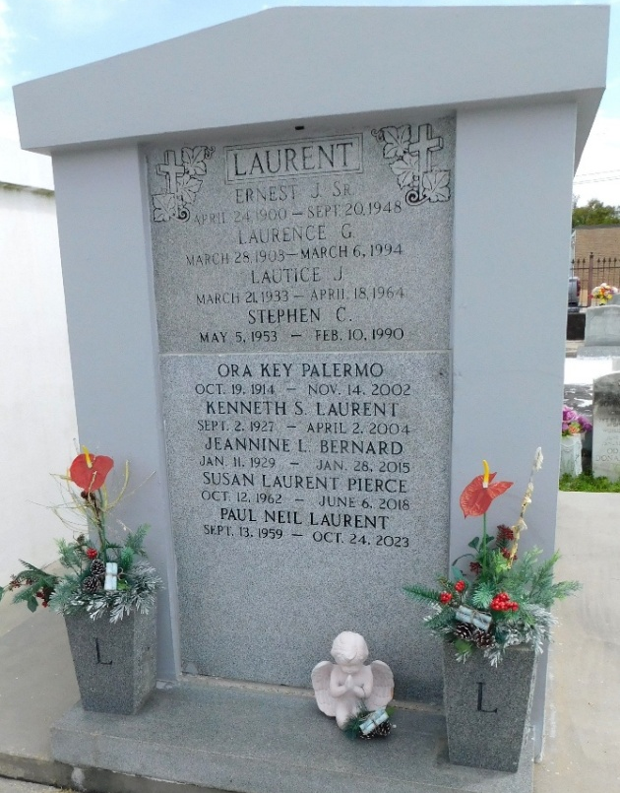
Photo by Mary Agnes Hammett

Paul Neil Laurent, age 64 and a resident of Bush, LA, passed peacefully on October 24, 2023 at 6:00 PM. Proud father of Miranda and Naomi Ora Laurent. Devoted son of the late Kenneth and Lautice Laurent and step-mother Margaret C., Loving brother of Anna L. Taylor (Dennis) and David Laurent. Preceded in death by siblings Stephen Laurent and Susan L. Pierce.
Paul cherished all his nieces: Anastacia Bergeron (Jake), Lautice Taylor, Samantha Pierce, Jackie Caton (Jared), great nieces Aurora and Audrey Bergeron and great nephew Michael C. Bergeron.
Special thanks to Anastacia Bergeron for her unwavering help and support.
Paul formerly worked as a Jet Aircraft Fuel Supervisor.
Relatives and friends are invited to attend a Funeral Mass at 11:00 AM on Thursday, November 2, 2023 at St. Peter Catholic Church, 1550 Hwy 44, Reserve, LA 70084. Visitation will be from 9:30 AM until 10:40 AM. Words of Remembrances will be from 10:40 AM until 11:00 AM. Interment will be in St. Peter Cemetery in Reserve, LA. In lieu of flowers, donations in Paul's honor can be made to any liver, pancreatic and kidney cancer societies.
Millet- Guidry Funeral Home, LaPlace, Louisiana
October 28, 2023

