Ramire John Laurent
April 10, 1892 – March 9, 1982

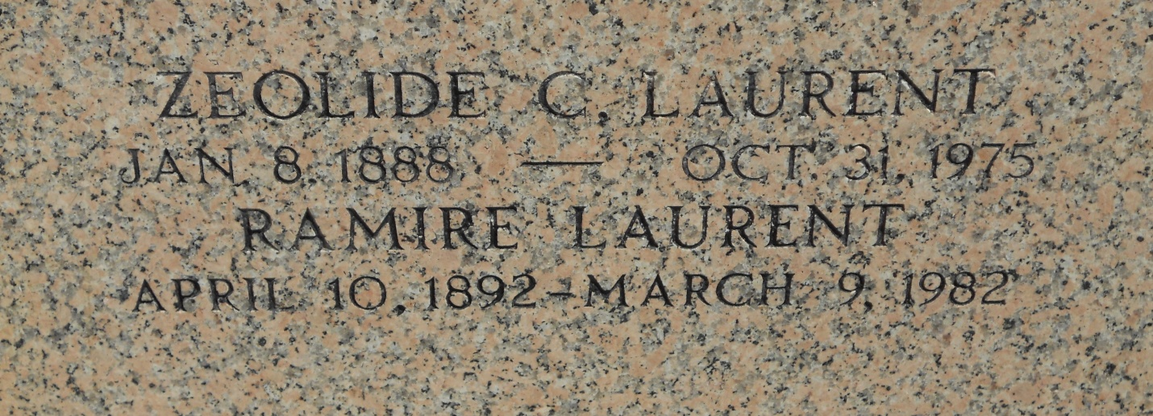
Photo by Team T-Lo

R. J. Laurent, on Tuesday, March 9, 1982 at 4:45 p.m., beloved husband of the late Zeloid [sic] Cambre, father of Lionel (Torriet) Laurent and Miriam Guidry, also survived by 5 grandchildren, age 89. A native of Wallace, La. and a resident of LaPlace.
Relatives and friends of the family are invited to attend the funeral services from Millet Funeral Home, LaPlace, on Thursday, March 11 at 10 a.m. followed by Religious services at St. Joan of Arc Catholic Church. Interment in St. Peters Cemetery, Reserve.
Friends may call from 5 until 10 p.m. on Wednesday, March 10 and from 8 a.m. until services on Thursday.

The Times-Picayune, New Orleans, Louisiana
Thursday, Mar. 11, 1982, Page 27

