Stephen C. Laurent
May 5, 1953 – February 10, 1990

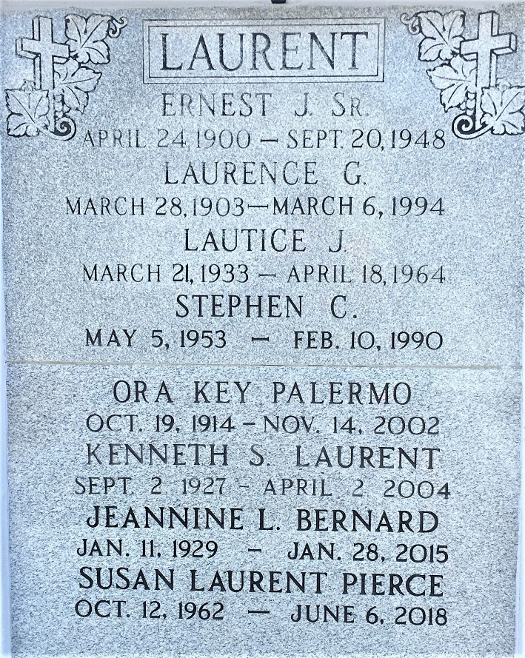
Photo by Team T-Lo

Funeral services were Feb. 12 for Stephen C. Laurent, 36, a native of New Orleans and resident of Baton Rouge, He died Feb. 10.
He is survived by his father and step-mother, Kenneth and Margaret Laurent of Reserve, maternal grandmother, Ora K. Plaermo of Bueche, a paternal-grandmother, Laurence C. Laurent of Reserve; siblings, Anna L. Vah of Bueche and Susan L. Pierce of Baton Rouge, David M. Laurent of Reserve, and Paul N. Laurent of Kenner, and three nieces.
Religious services were at St. Joseph Cathedral, with interment at St.Peter's Cemetery in Reserve.

L'Observateur, LaPlace, Louisiana
February 22, 1990

