Zeolide (Cambre) Laurent
January 8, 1888 – October 31, 1975

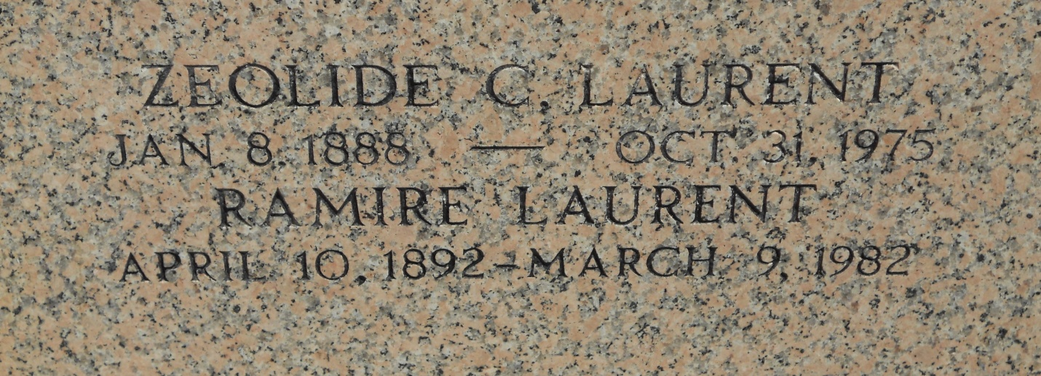
Photo by Team T-Lo

Age 87 years, a native and resident of Laplace, Louisiana.

Wife of Ramire Laurent of Laplace. Mother of Lionel (Torriet) Laurent of Laplace, and Mrs. Joseph A (Miriam) Guidry of Luling, Louisiana. Sister of Miss Camille Cambre and Mrs. Aimee Becnel, both of Norco, Louisiana.

Services were Monday 3 Nov 1975 at St Joan of Arc Church, Laplace, with interment in St Peter Cemetery, Reserve, Louisiana.

The Times-Picayune, New Orleans, Louisiana
2 Nov 1975

