Albert J. LeBlanc
September 19, 1927 – July 21, 2010

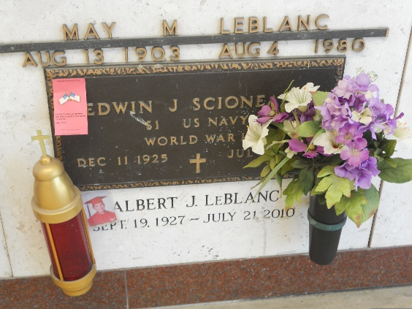
Photo by Team T-Lo

Albert J. LeBlanc passed away on Wednesday, July 21, 2010 at the age of 82. He shared 60 years with his beloved wife, Gladys Roussel LeBlanc.
He was the son of Robert Joseph and Zula May Jacob LeBlanc. He was the bother of Freida L. Rizzuto, Carol LeBlanc, Robert LeBlanc, Jr., Frances (Bird) LeBlanc and the late Betty L. Scioneaux. He was the loving father and father-in-law of Kenneth LeBlanc and Penny, Sandra L. Bercegeay and Andrew, Debra L. Terrio and Christopher, Stephen (Paul) LeBlanc and Elizabeth, Cindy L. St. Germain and Bruce, Brian LeBlanc and Eleanor and the late Connie L. Logarbo and Johnny. He leaves behind 16 grandchildren and 9 great-grandchildren. He is greeted in heaven by 1 grandson. He is also survived by a host of nieces, nephews, cousins and in-laws. He was a native and resident of Reserve.
Relatives and friends are invited to attend services. Visitation at St. Peter Catholic Church, Reserve on Friday, July 23, 2010 from 9:00 AM until 11:00 AM. Followed by a Mass at 11:00 AM. Burial will be in church cemetery. Arrangements by Millet - Guidry Funeral Home, LaPlace.

The Times-Picayune, New Orleans, Louisiana
July 22, 2010

