Charlene (Maurin) LeBlanc
November 24, 1941 – January 25, 2008

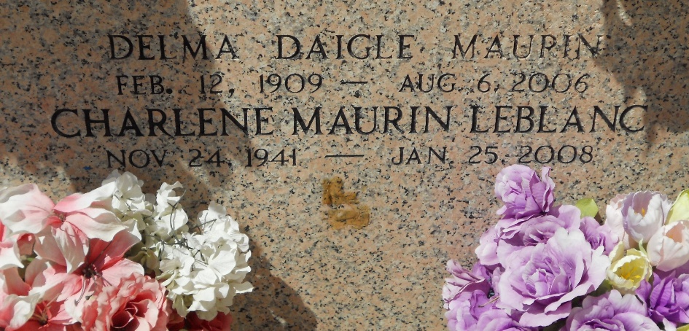
Photo by Team T-Lo

On Friday, January 25, 2008, at River Parishes Hospital, LaPlace, LA at 11:15 p.m., Charlene Maurin LeBlanc went home to be with the Lord at the age of 66.
She was born on November 24, 1941, to the union of Etienne and Delma Maurin of Reserve, LA.
She was a member of New Wine Christian Fellowship.
She leaves to cherish her memories: her beloved husband, Robert J. LeBlanc Jr.; sons: Joseph, James, Jonathan, Jerry and Jacob LeBlanc of Reserve, LA; Jeffery and Jason LeBlanc of Lutcher, LA; two daughters: Belinda LeBlanc of Reserve, LA and Dawn L. Andros of Metairie, LA; six daughters-in-law, one son-in-law; sibling: Etienne Maurin of LaPlace, LA, Paul Maurin of Reserve, LA and Johnny Maurin of Provo, Utah; three sisters-in-law; two aunts: Leotha Hymel and Valerie Freeman; uncle, Wilson Daigle; a devoted cousin, Elaine Duhe of Reserve, LA; 19 grandchildren, 2 great-grandchildren, a host of nieces, nephews, cousins and friends.
She was preceded in death by her parents, Etienne and Delma Maurin, mother and father-in-law, Robert and Mae Jacob LeBlanc.
Relatives and friends of the family, also members of Reserve Church and neighboring churches are invited to attend a MEMORIAL Service at 3:00 p.m. on Sunday, January 27, 2008, at New Wine Christian Fellowship, 1929 W. Airline Highway, LaPlace, LA.
Arrangements by Richardson Funeral Home of Jefferson.

The Times-Picayune, New Orleans, Louisiana
January 27, 2008

