Gladys (Roussel) LeBlanc
January 14, 1928 – June 19, 2012

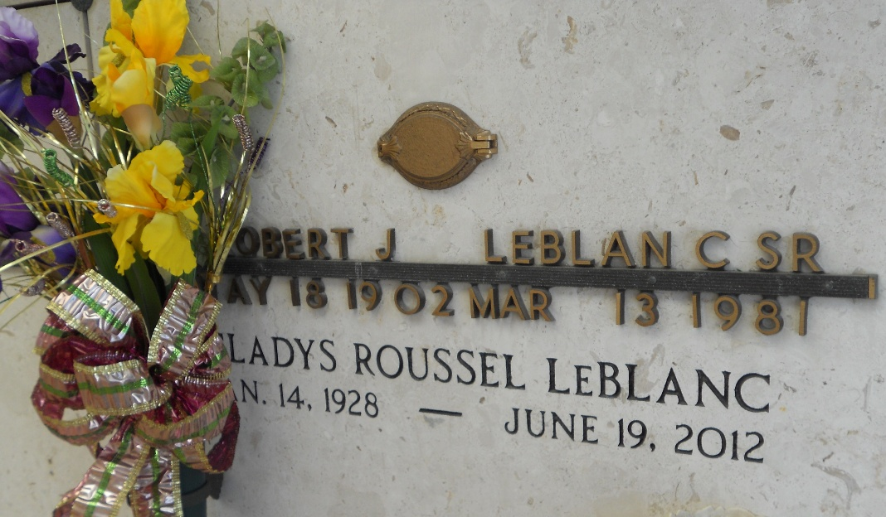
Photo by Team T-Lo

Gladys Roussel Le Blanc, 84 of Reserve, Louisiana surrendered to God on June 19, 2012 after her struggle with pneumonia.
Wife of the late Albert J Le Blanc of Reserve, La. Survived by her twin sister Gloria Roussel Babin , and in-laws Robert Le Blanc Jr, Carol Le Blanc, Freida Le Blanc Rizzuto and Frances Le Blanc. Preceded in death by her parents Romeo and Lucress Schexnayder Roussel of Paulina, La. and brothers Ray, Raymond, Roland, Herbert and Leo Roussel and sister-in-law Betty Le Blanc Scioneaux. a daughter Connie Le Blanc Logarbo and a grandson Challing Le Blanc. She is survived also by her children Kenneth "Kosh" Le Blanc(Penny), Sandra Le Blanc Bercegeay (Andrew), Debra Le Blanc Terrio (Christopher), Stephen Paul Le Blanc,Cindy Le Blanc St Germain (Bruce), and Brian Le Blanc (Eleanora). Gladys was a Mother, Grandmother, Step Grand Mother and Great Grandmother that attended every milestone, cheered on every athletic event and celebrated every achievement of ours. Gladys was totally loved and appreciated by her 17 Grandchildren, 3 Step Grandchildren, 10 Great Grandchildren and 4 Step Great Grandchildren. She will truly be missed but her spirit and devotion to us all will be felt everyday and in every challenge that we will encounter because of the strength and confidence she has instilled in us.
Relatives and friends are invited to attend services. Visitation at St. Peter Catholic Church, Reserve, LA on Thursday June 21, 2012 from 8:00am to 10:00am, followed by Mass at 10:00am. Burial in St. Peter Cemetery. Arrangements by Millet-Guidry Funeral Home, LaPlace, LA.

The Times-Picayune, New Orleans, Louisiana
June 19-20, 2012

