Gloria “Fay” (Duhe) LeBlanc
December 6, 1934 – May 14, 2018

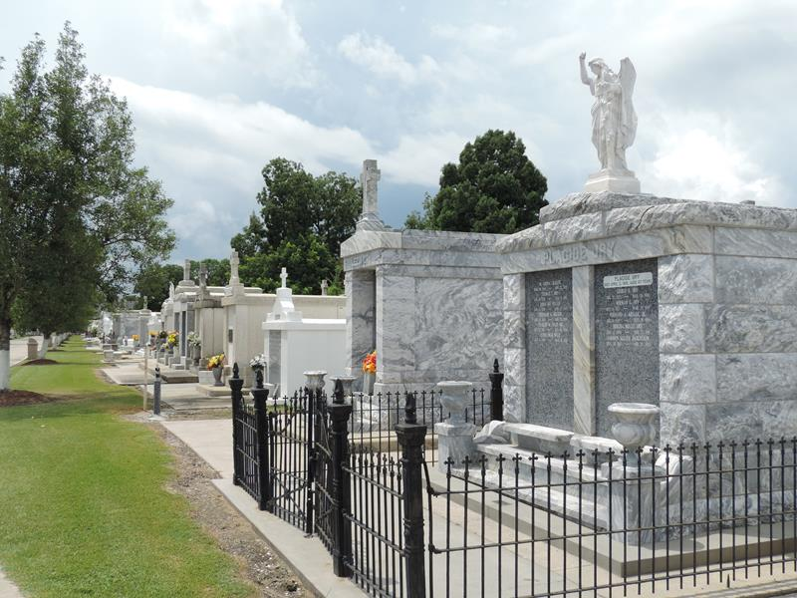

Gloria "Fay" Duhe LeBlanc, 83, a native and resident of Reserve, LA passed away on May 14, 2018.

A visitation will be held in her honor on Saturday, May 19, 2018 at St. Peter Catholic Church - Reserve, LA from 9:00 am until the Mass of Christian Burial at 11:00 am. The burial will follow in St. Peter Cemetery, Reserve, LA.

She was the beloved wife of Carol Joseph LeBlanc for 60 years; and mother of Melanie L. Trosclair (Ricky) and Leslie L. Albrecht. LeBlanc was the daughter of the late Maurice Duhe and Lucette Williams Duhe; step-mother, Violet Boudreaux Duhe; brothers, Vernon Duhe (Pearl Ann) and Ronald Duhe (Janet); sister, Barbara Duhe Elder Champagne (Hardy and Herb). She was the grandmother of Tiffany Albrecht, Stephanie T. Salomon (Greg), Ritchie Trosclair (Ashley), Ashley T. Teague (Timmy), and Corey Albrecht; and great-grandmother of Kayla, Krysta, Jonathan, Kylie, Klaire, Kenzie, Quinn, and Ezra.

Rose Lynn Funeral Home, Lutcher, Louisiana

