Hattie (Bourg) LeBlanc
April 19, 1920 – November 9, 2015

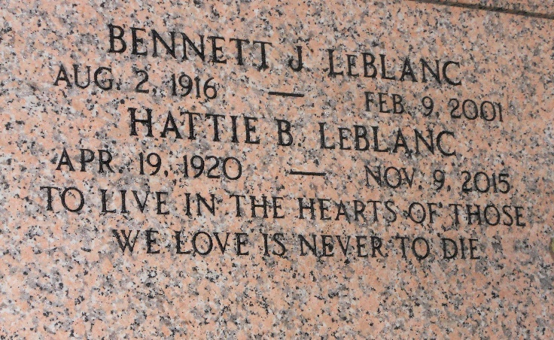
Photo by Team T-Lo

Hattie "Meone" Bourg LeBlanc, age 95, entered peacefully into heaven on Monday, November 9, 2015, at Canon Hospice in Jefferson, LA. A lifelong resident of Lafitte, LA for 77 years and a native of Terrebonne Parish, LA.
Beloved wife of the late Bennett J. LeBlanc for 63 years. She is survived by her children, Betty Jane L. Lavelle (Michael) and Larry A. LeBlanc (Diane) and a proud grandmother of Kevin, Patrick and Daniel Lavelle and Rebecca L. Kerner, Larry, Jr., and Lee LeBlanc and Tina L. Bourgeois. Great grandmother of Jacob and Emma Lavelle, Tristian and Madison Kerner, Steven LeBlanc and Magen L. Thompson, Justin LeBlanc, Jeremy and Caleb Grego.
Daughter of the late Emelia Bellamore and Victor Bourg. She was preceded in death by her 12 siblings. She is also survived by numerous loving nieces, nephews, other relatives and friends.
Relatives and friends are invited to attend a Funeral Mass at Westside Leitz-Eagan Funeral Home, 5101 Westbank Expy., Marrero, LA on Friday, November 13, 2015 at 1:00 PM. Visitation from 10:00 AM until Mass time. Interment following in St. Peter's Mausoleum Cemetery in Reserve, LA.

New Orleans Advocate, Louisiana
Nov. 10 to Nov. 13, 2015

