Felix Andrew LeBoeuf
May 21, 1928 – May 15, 2005

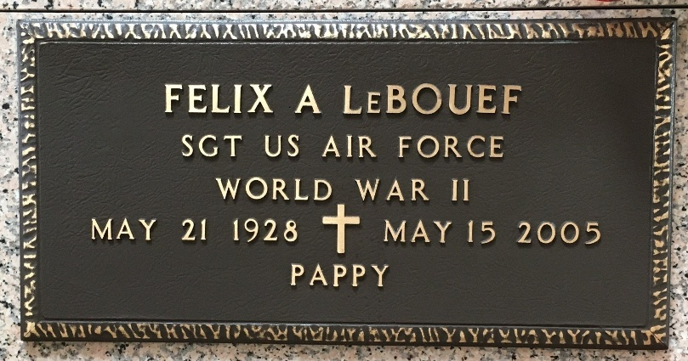
Photo by Team T-Lo

Felix A. "Pappy'' LeBouef on Sunday May 15, 2005 at 9:07 PM.
Beloved husband of Yvonne Marie Cambre LeBouef. Father and father in-law of Lionel and Lindy LeBouef, Michael Sr. and Lindarae LeBouef, Joy L. Jones and the late Vicki LeBouef. Father-in-law of Gary Louque. Grandfather of Kirk and Michael LeBouef, Jr., Brandon and Beth Louque, Estelle, Brooke and Philip Jones, Jr. Great-grandfather of Brayden Louque.
Son of the late Ulysses and Rosa Faris LeBouef. Brother of Edna Gautreaux, Ruth Mae Gauthier and the late Gerald, Harold ''Chick'', Thomas, Raymond, Earl and Anna Margaret LeBouef.
Age 76, a native of Convent and a resident of Garyville for the past 75 years.
Relatives and friends of the family, also employees of St. John the Baptist Parish School Board are invited to attend services. Visitation at St. Hubert Catholic Church, Garyville, on Tuesday, May 17, from 5-10 PM, and on Wednesday from 9-11 AM, followed by religious services at the church at 11 AM. Burial in St. Peter Cemetery, Reserve, LA. Arrangements by Millet-Guidry Funeral Home, Laplace, LA.
The Times-Picayune, New Orleans, Louisian
May 17, 2005

