Michael Andrew LeBoeuf
October 2, 1962 – June 19, 2009

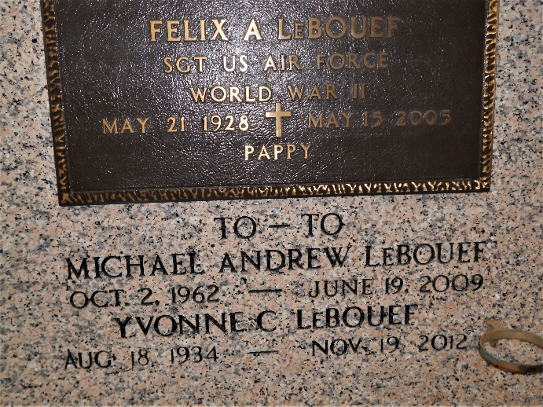
Photo by Team T-Lo

Michael "To-To" LeBouef on Friday, June 19, 2009 at 7:30 AM.
Beloved husband of Lindarae LeBouef. Father of Michael LeBouef, Jr. Stepfather of Toby Duhe and Danielle Tyrrell. Grandfather of Brea Ellis, Eric and Alyson Tyrrell, Sarah Duhe, Michael LeBouef III and Tayden Haydel.
Son of Yvonne Marie Cambre LeBouef and the late Felix (Pappy) LeBouef.
Brother of Lionel LeBouef, Joy Jones and the late Vicki LeBouef. Age 46 years. A native and resident of Garyville, La.
Relatives and friends are invited to attend services. Visitation at Millet-Guidry Funeral Home, 2806 W. Airline Hwy., LaPlace, La. on Sunday, June 21, 2009 from 5:00 PM to 9:00 PM and on Monday from 8:00 AM to 9:30 AM. Followed by a Mass at St. Hubert Catholic Church, Garyville, La at 10:00 AM.
Burial in St. Peter Cemetery, Reserve, La.
The Times-Picayune, New Orleans, Louisiana
June 20, 2009

