Nelwyn (Oubre) LeBoeuf
October 15, 1933 – June 23, 2024

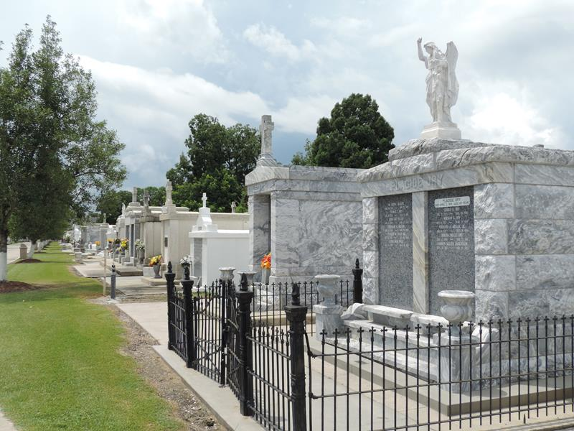

Nelwyn Oubre LeBoeuf, a native of Garyville, LA, was born on 10/15/1933 and passed away peacefully with the comfort of family on 6/23/2024, in Lawrenceville, GA. She was devoted to her faith, family, and community. Nelwyn served the parish of St. Hubert’s Catholic Church in Garyville for many years as a catechist for the youth, a Eucharistic minister and a member of the Ladies Altar Society. She was a member of the local VFW Auxiliary and a member of The Retired & Senior Volunteer Program for over 25 years. She served as a community advisor for local industries and volunteered at the SELA Veterans Home and local nursing homes. Nelwyn was the heart of her family. She was loving, kind and generous with her time and talents. She was an effective leader with a joyful spirit and a wonderful role model to her family, friends and community.
Nelwyn is survived by brothers Earl, Rodney, Warren and Rene III Oubre and sister, Carolyn Oubre-McClure; sons and their spouses, Larry (Karen), Willie III (Lisa) & Todd (Janet) LeBoeuf, 12 grandchildren, 21 great-grand-children and 4 great-great grandchildren. She is preceded in death by her parents, Rene A. Jr. and Leona Troxler Oubre; sisters, Doris Jacob and Lois Falgoust; her beloved husband, Willie J. LeBoeuf, Jr.; their son and spouse, Darol (Debra); and loving companion of recent years, CD Clement, Jr.
Services will be held at St. Hubert’s Catholic Church in Garyville on Saturday, June 29th. Visitation will begin at 9 am followed by a Mass of Christian Burial at 11:00 and entombment in St. Peter’s Cemetery in Reserve.
The family would like to express its gratitude to extended family & friends; Azalea Estates of Gonzales, LA; Piedmont East Hospital, Snellville, GA; Delmar Gardens of Gwinnett, GA; the clergy, staff and the Ladies Altar Society of St. Hubert’s Catholic Church; and Millet-Guidry Funeral Home for the prayers and the compassionate care of Nelwyn.
In lieu for flowers, please consider a donation to the Dementia Society of America, Parkinson's Foundation or your preferred charitable organization in Nelwyn's memory.

Millet-Guidry Funeral Home, LaPlace, Louisiana

