Yvonne Marie (Cambre) LeBoeuf
August 18, 1934 – November 19, 2012

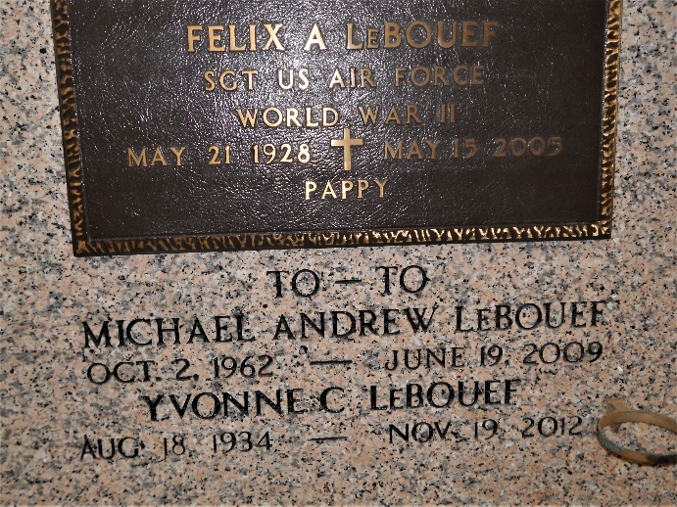
Photo by Team T-Lo

Yvonne Cambre LeBouef was born on August 18, 1934 and passed away on Monday, November 19, 2012. Yvonne was a resident of Garyville, Louisiana.
Beloved wife of Felix (Pappy) LeBouef. Mother of Lionel LeBouef (Lindy), Joy L Jones, and the late Michael LeBouef Jr. (Lindarac) and Vicki L. Louque.
Grandmother of Kirk and Michael LeBouefJr., Brandon Louque, Estelle, Brooke, and Philip Jone Jr. Also, survived by numerous great-grandchildren.
Daughter of the late Lionel and Berndette Cambre. Sister of Betty Cambre Kelly. Age 78. A native and resident of Garyville, LA.
Relatives and friends are invited to attend services. Visitation at Millet-Guidry Funeral Home, 2806 W. Airline Hwy. LaPlace, LA on Wednesday November 21, 2012 from 10:00 to 12:00 pm, followed by Religious Services in the Funeral Home Chapel at 12:00 noon. Buriel in St. Peter Cemetery, Reserve, LA.
The family would like to thank Twin Oaks Nursing Home, River Parish Hospital and LaPlace Dialysis.
The Times-Picayune, New Orleans, Louisiana
June 20, 2009

