Mai D. LeBrun
May 15, 1898 – December 9, 1978

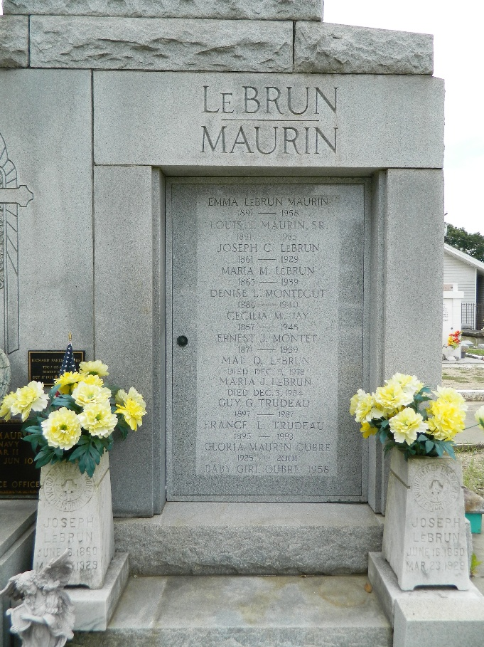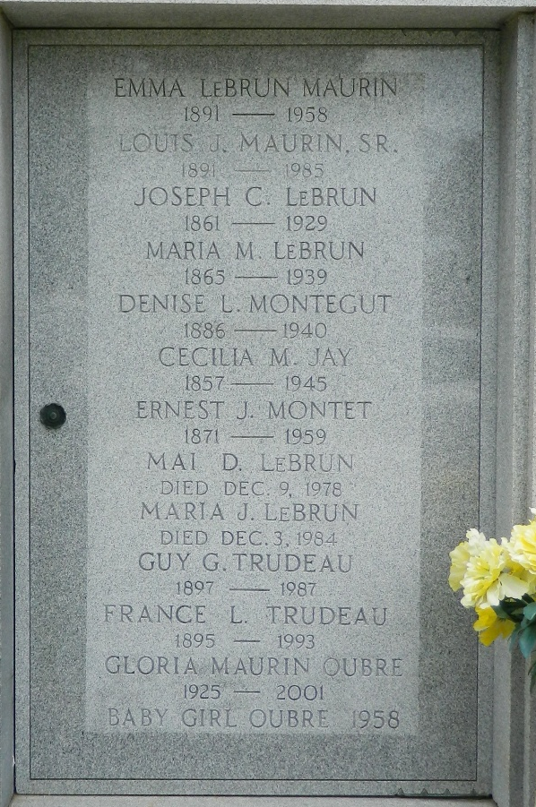

Miss Mae LeBrun, of Reserve, La, on Saturday December 9, 1978, at 7:29 o'clock a.m., beloved daughter of the late Joseph C and Maria Montet LeBrun; sister of Mrs. France L Trudeau, Miss Maria J LeBrun, both of Reserve, La, the late Misses Luce, Lucille, and Eugenie LeBrun, Mrs. Denise L Montegut, and Mrs. Emma L Maurin, a native and resident of Reserve, La.

Relatives and friends of the family are invited to attend the funeral. Services from Millet Funeral Home, Reserve, La, on Monday December 11, 1978 at 10 o'clock a.m., followed by religious services at St Peter Catholic Church, Reserve, La. Interment St Peter Cemetery.
The Times-Picayune, New Orleans, Louisiana
December 10, 1978

