Maria Joseph LeBrun
May 10, 1896 – December 3, 1984

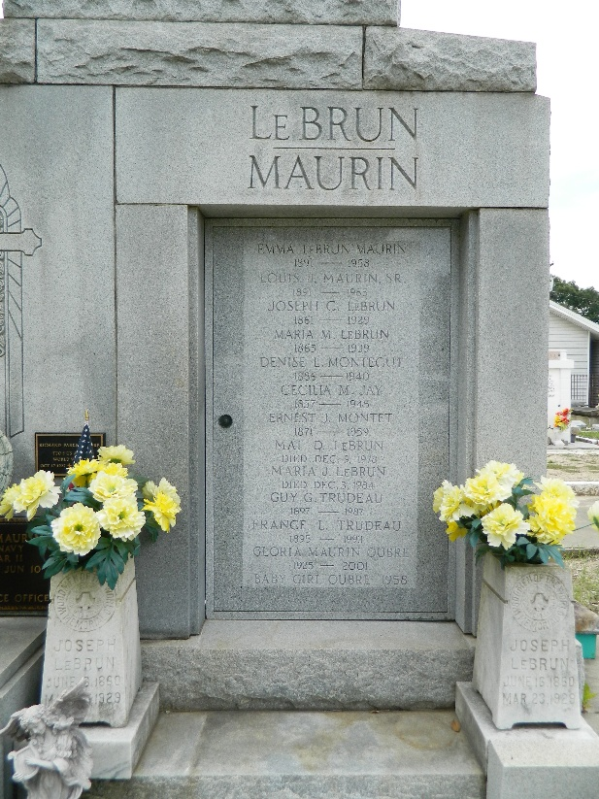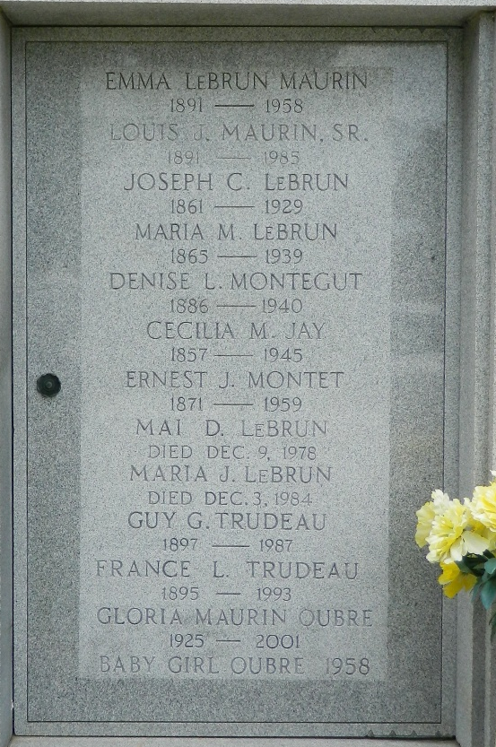

Maria Joseph LeBrun on Monday, December 3, 1984 at 10:50 o'clock PM.

Beloved daughter of the late Joseph Carl LeBrun and Maria Montet. Sister of Mrs. Frances L Trudeau, also the late Denise Montegut, Emma Maurin, Mai Luce and Lucille LeBrun. Also survived by many nieces and nephews.

A native and resident of Reserve. Miss LeBrun was a retired teacher in the Public School System of St John the Baptist Parish for over 33 years.

Relatives and friends of the family are invited to attend the funeral services from Millet Funeral Home, Reserve, La, on Wednesday, December 5, 1984 at 1 o'clock PM. Followed by a Mass of Christian Burial at St Peter's Catholic Church, Reserve, La. Interment in church cemetery.
Unknown source

