Maria (Montet) LeBrun
October 31, 1865 – February 17, 1939

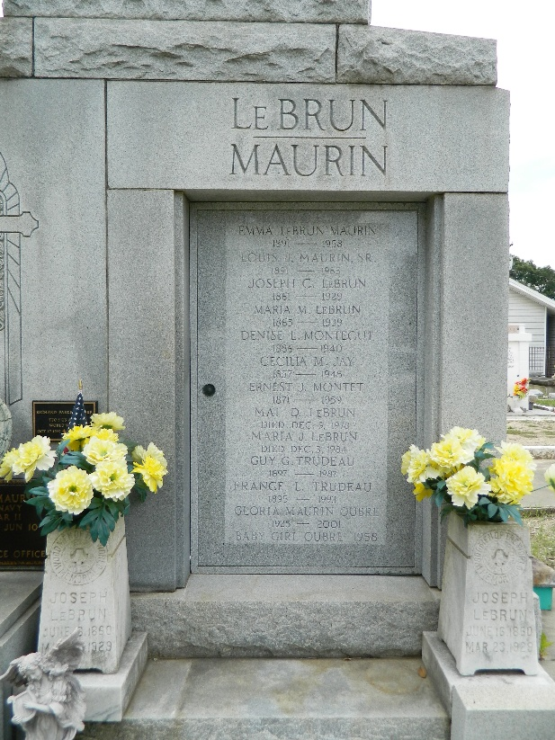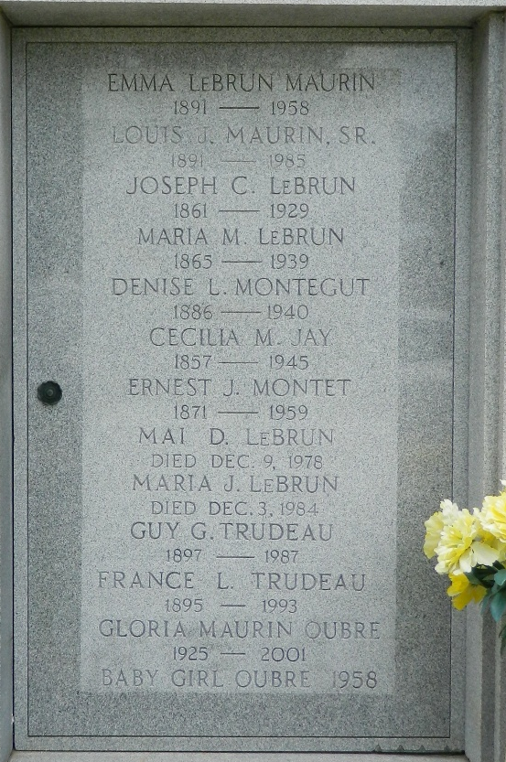

Maria Montet, wife of Joseph C Le Brun, died Friday 17 Feb 1939 at 4:50 a.m. at age 73 years, 3 months and 17 days.

She was a native of Roche Chalais, Department de la Dordogne, France, and a resident of St John Parish, Louisiana, for years.

She was the mother of Mrs. J J Montegut, Mrs. L J Maurin, Mrs. Guy Trudeau, Maria and Mai Le Brun and the sister of Mrs. C Jay and E Montet.

Services were Saturday 18 Feb 1939 at St Peter Church, Reserve, Louisiana, with interment in St Peter Cemetery, Reserve.
The Times-Picayune, New Orleans, Louisiana
December 10, 1978

