Audrey (Bourgeois) LeRoux
October 10, 1924 – June 18, 2015

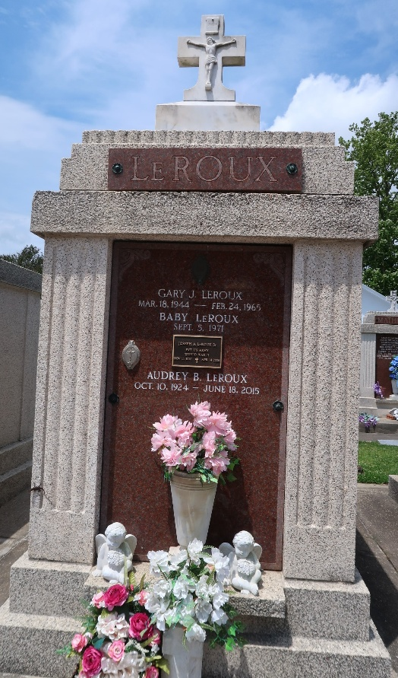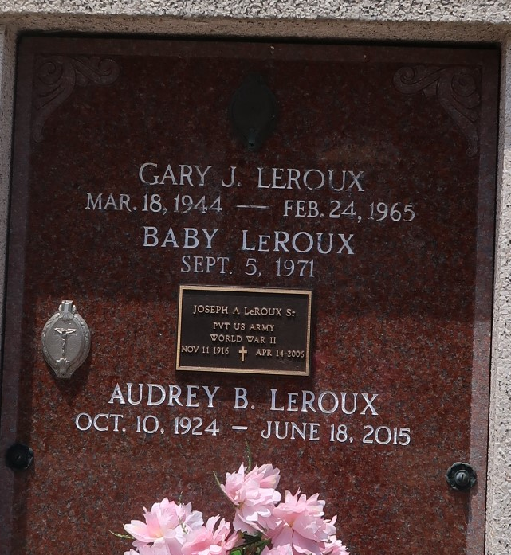

Audrey Bourgeois LeRoux passed away on Thursday, June 18, 2015 in Reserve at the age of 90. A retired lunchroom worker at Godchaux Elementary School for over 30 years. She was a resident of Gramercy and moved to Reserve in 1945.
Beloved wife of the late Joseph A. LeRoux, Sr. Mother of Gail Louque (late, Johnny), Dianne Breaud (Putt), Terry LeRoux (Karlee), Joseph LeRoux, Jr. (Emma) and the late Gary LeRoux. Grandmother of 10 grandchildren, 14 Great grandchildren and 7 Great-great grand-children. Daughter of the late Joseph T. Bourgeois, Jr. and Lena Trosclair Bourgeois. Sister of Lawrence Bourgeois and the late Aline Mancuso, Bertha Morrison, Ethel Rizzuto, Jeanette Duhe, Joseph L. Bourgeois, Lester Bourgeois, Melvin Bourgeois and Posey Bourgeois.
The family would like to thank Passage Hospice and caregivers Gail Jumonville and Angie Blouin.
Relatives and friends are invited to attend the Funeral Mass at St. Peter Catholic Church, 1550 Hwy 44, Reserve on Monday, June 22, 2015 at 11:00 a.m. Visitation will begin in church at 9:00 a.m. Interment to follow in St. Peter Cemetery.

Millet-Guidry Funeral Home, LaPlace, Louisiana

