Joseph A. LeRoux Sr.
November 11, 1916 – April 14, 2006

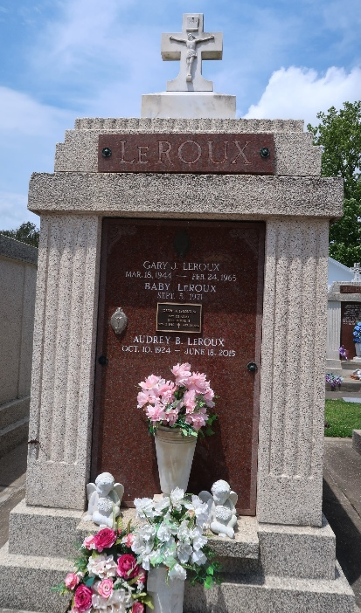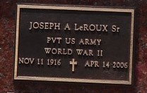

Joseph A. LeRoux, Sr. on Friday, April 14, 2006 at 12:10 a.m.
Beloved husband of Audrey Bourgeois LeRoux. Father of Gail Louque, Diann Breaud, Terry LeRoux, Joseph LeRoux Jr. and the late Gary LeRoux. Brother of the late Marie Cambre, Pauline Buras and Ann Kailing. Also survived by 10 grandchildren, 17 great-grandchildren and 2 great-great-grandchildren. Age 89. A native of Plaquemine, LA and a resident of Reserve, LA for the past 68 years.
Relatives and friends of the family are invited to attend services. Visitation at St. Peter Catholic Church, Reserve on Monday, April 17, 2006 from 10:30 a.m. to 12:30 p.m. followed by Religious services at the church at 12:30 p.m. Burial in church cemetery. Arrangements by Millet-Guidry Funeral Home, LaPlace.

The Times-Picayune, New Orleans, Louisiana
April 15, 2006

