Chester Lee Sr.
February 11, 1924 – July 3, 2012

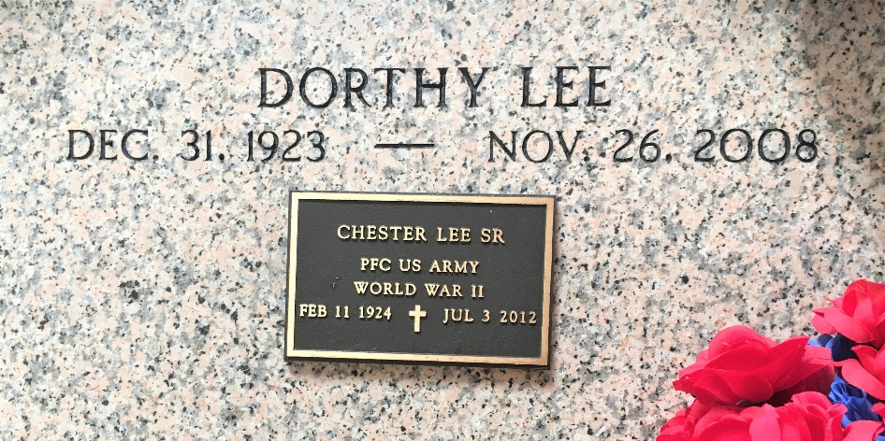
Photo by Team T-L0

Chester Lee, Sr. quietly departed this life on Tuesday, July 3, 2012 at East Jefferson General Hospital in Metairie, LA. Chester was the beloved husband of the late Dorothy Esther Lee. He is a retired veteran of World War II and a retiree of Celotex Corporation in Avondale, LA (39 yrs. of service).
He leaves cherished memories to one son, Chester Lee, Jr. (Jean) of Beaumont, TX; one daughter, Dianne L. Pidgeon (Wilman) of Huntsville, AL; one sister, Mildred L. Norbert; six grandchildren; three great grandchildren; a devoted cousin, Ella W. Goudia all of Garyville, LA; a host of nieces & nephews; relatives & friends. Age 88 years. A native and resident of Garyville, LA.
Relatives, friends of the family; pastors, officers and members of True Light B.C., all neighboring churches are invited to attend the funeral services at True Light B.C., Little Hope St., Garyville, LA, Rev. Wesley Anderson, Sr. pastor, Rev. James Davis, officiating on Saturday, July 7, 2012 at 11:00am. Visitation from 9:00am until funeral. Interment St. Peter Catholic Church Cemetery. No Wake. Services entrusted to Baloney Funeral Home, 399 Earl Baloney St., Garyville, LA. 985-535-2540.

The Times-Picayune, New Orleans, Louisiana
Jul. 5 to Jul. 6, 2012

