Rachel (Millet) Lehmann
October 7, 1954 – May 26, 2018

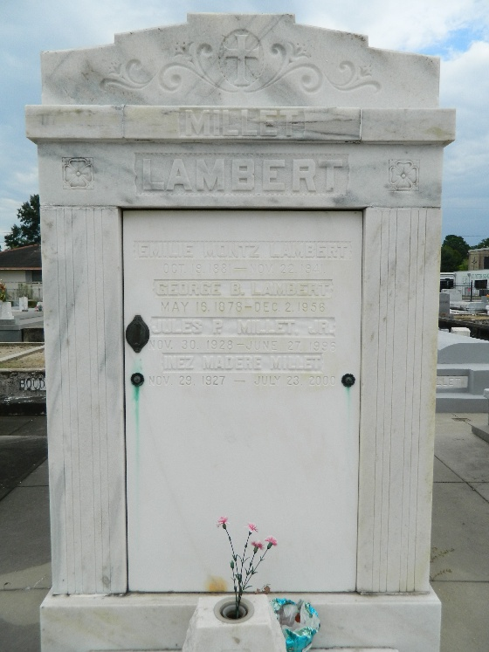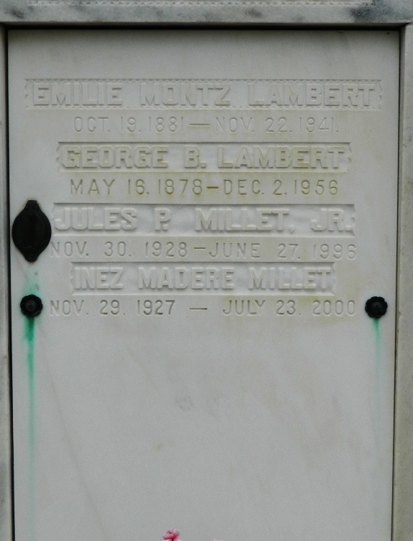

Rachel Millet Lehmann passed away on Saturday, May 26, 2018 in Covington, LA. She was born on October 7, 1954 in New Orleans, LA to the late Jules Peter Millet, Jr. and Inez Madere Millet.
Rachel was married to her beloved husband, Gustave J. Lehmann III, for 43 years. She was the loving mother of Natalie L. Dewey (Tyler), Gustave J. Lehmann, IV (Wendy), and Shaun M. Lehmann. Rachel was the proud grandmother of Catherine Dewey, McKenzie Dewey, Ella Dewey, Sydney Lehmann, Sadie Lehmann, and Shaun Michael Lehmann. She was the sister of Catherine M. Bakewell (Roy), Suzanne M. Klibert (Richard), Danny J. Millet (Henrietta), and Marcelle M. Bailey (EJ). Rachel was the sister-in-law of Norma L. Vice (Wes). She is also survived by an abundance of nieces, nephews, cousins, and friends.
In lieu of flowers, please make donations in memory of Rachel Millet Lehmann to Church of the King's Global Mission Legacy Fund. She was our urban missionary, but her goal was to reach the world.
Relatives and friends are invited to the Funeral Service at Church of the King, 22205 Little Creek Rd., Mandeville, LA 70471 on Friday, June 1, 2018 at 12:00 Noon with visitation from 10:00 AM until service time.

The New Orleans Advocate, Louisiana
May 30 to Jun. 1, 2018

