Bernard Phillip Lemoine
September 9, 1942 – January 21, 2014

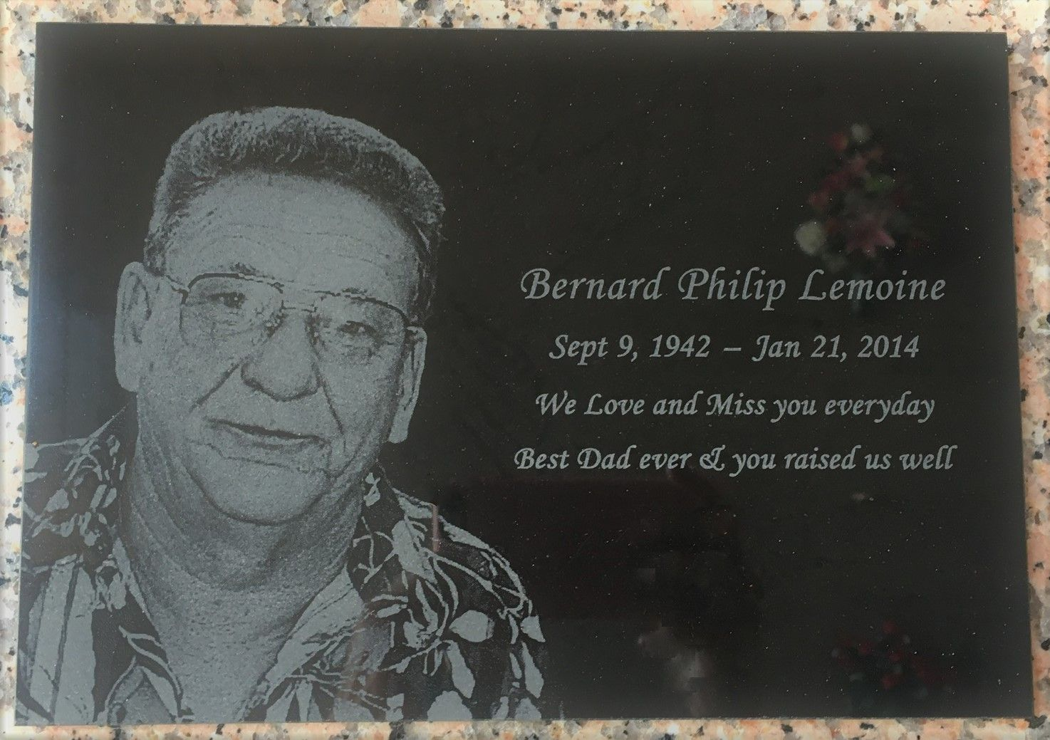
Photo by Team T-Lo

Bernard P. Lemoine died on Tuesday January 21, 2014, Beloved husband of Terry Terrio Lemoine. Father of Tammy Lemoine (Stacey) and Lacie L. Fabre (A.J.). Grandfather of Justin and Cameron Tumminello and Madison Levandoske. Son of the late Avide and Agatha Ducote Lemoine. Brother of Ossie, Earl and Reiser Lemoine and the late John Leary and Gerald Lemoine. Age 71. A native of Plaucheville, LA former resident of Metairie and a resident of Garyville.

Relatives and friends are invited to attend services. Visitation at Millet-Guidry Funeral Home, 2806 W. Airline Hwy., LaPlace, LA on Monday January 27, 2014 from 9:00am to 10:30am, followed by Mass at St. Peter Catholic Church, Reserve, LA 11:00am. Burial in St. Peter Cemetery, Reserve, LA.
The New Orleans Advocate, Louisiana
January 23-23, 2014

