Carl Leslie Levet Jr.
November 9, 1943 – August 29, 1982

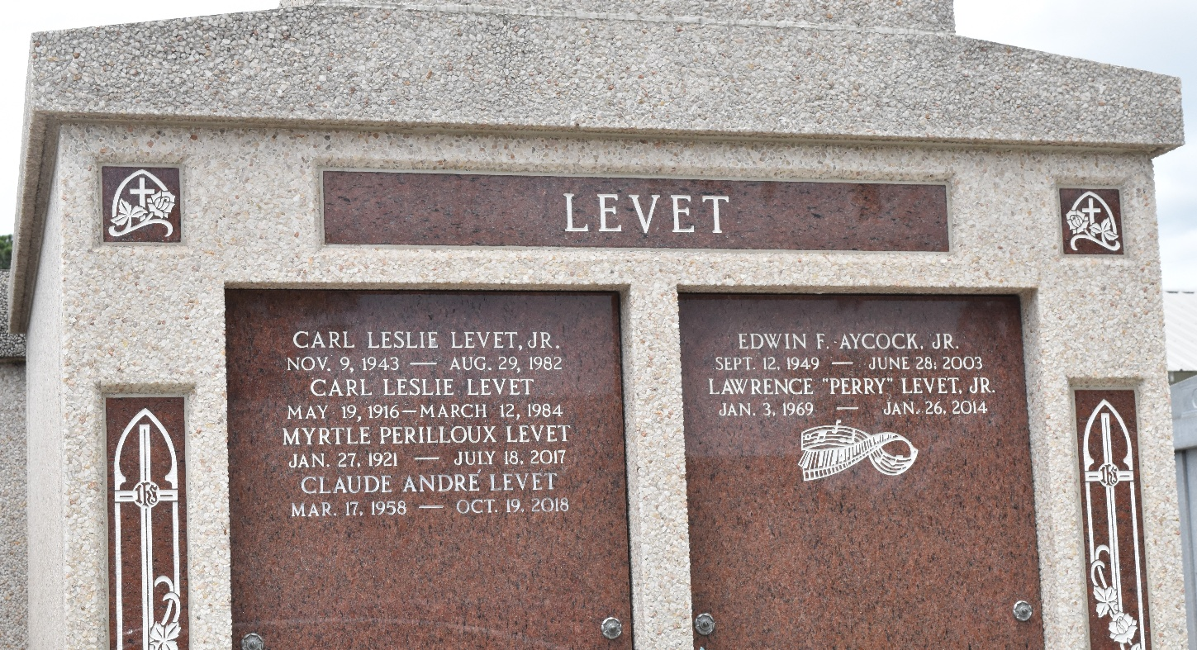

Carl (Pusty) Levet Jr., on Sunday, August 29, 1982 at 5:00 p.m. Beloved husband of Linda Millet, son of Carl Leslie Sr., and Myrtle Levet, brother of Larry, Claude, Jacque, and Angelique Levet, Emily Hogan, and Yvette Dornier. Age 38. A native of Garyville, and a resident of Laplace for the past 14 years.

Relatives and friends of the family are invited to attend the funeral services from Millet Funeral Home, Laplace, on Tuesday, August 31, 1982, at 11:15 a.m. followed by religious services at St. Joan of Arc Catholic Church. Interment St. Peter Cemetery, Reserve. Friends may call from 5:00 to 11:00 p.m. on Monday, August 30, 1982 and from 8 a.m. until services on Tuesday.

Unknown newspaper clipping

