Claude Harold Levet
January 11, 1909 – March 17, 1982

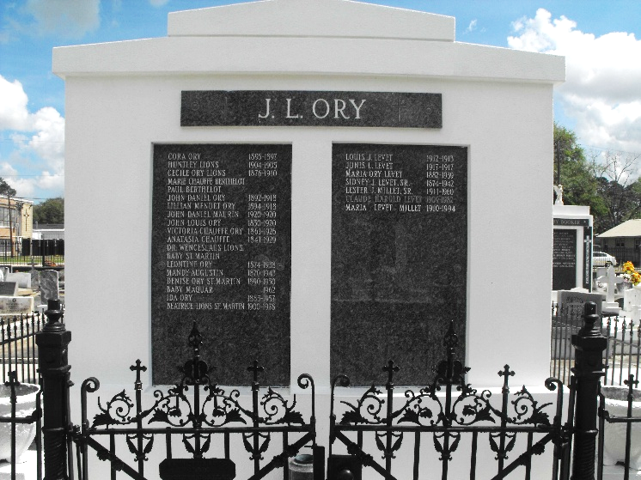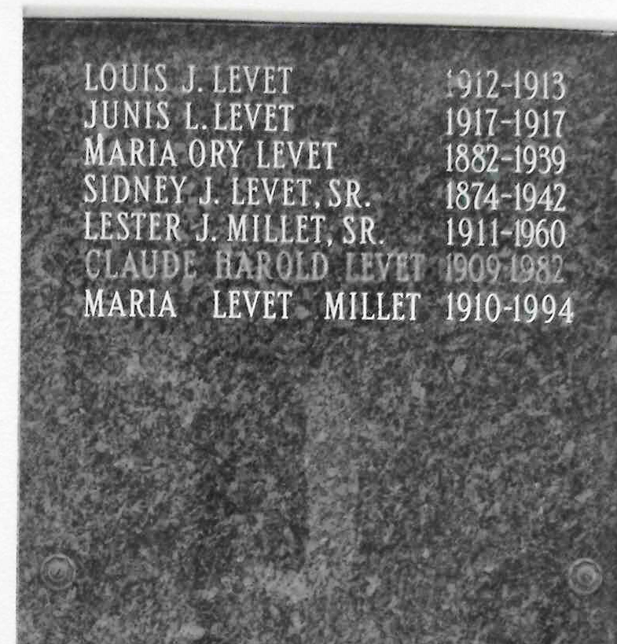
Photos by Mary Agnes Hammett

Claude H. Levet on Wednesday, March 17, 1982, at 1:30 a.m., beloved son of the late Maria V. Ory and Sidney J. Levet Sr., brother of Maria L. Millet, Joy L. Lodrigues, Carl Leslie Levet Sr., and the late Sidney J. Levet jr., also survived by several nieces and nephews. Age 73. A native and resident of San Francisco Plantation.

Relatives and friends of the family are invited to attend the funeral services from Millet Funeral Home, Reserve, on Thursday, March 18, at 11:00 a.m. followed by Religious Services at St. peter’s Catholic Church. Interment in Church Cemetery. Friends may call from 8:00 a.m. on Thursday, March 18 until services at 11:00 a.m.

Unknown newspaper clipping
Contributed by Sidney Levet

