Jo Ann (Madere) Levet
August 19, 1947 - March 18, 2024

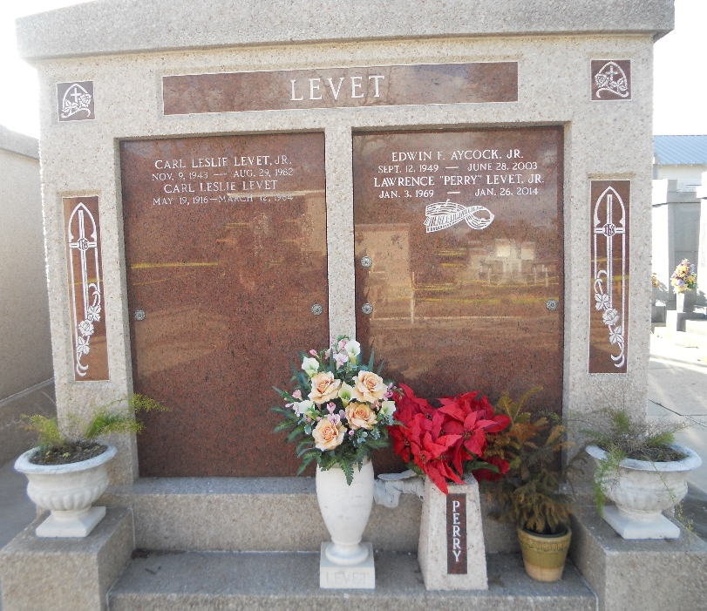
Photo by Team T-Lo

Jo Ann Madere Levet passed away peacefully surrounded by her family on Monday, March 18, 2024, at the age of 76 after a courageous battle with Parkinson’s. She grew up in LaPlace, Louisiana, was a long-time resident of Garyville, and lived in Hammond for the past 12 years.
Jo Ann was a loving wife of 56 years to Larry Levet; devoted mom to Shelly Ernst (Lester), Kelly Curtis, and Angelle Farrell (Bart); adoring Mammy to her grandchildren: Jordan (Grace), Gabrielle, Leslie, Jeanne, Courtney, Madeleine, Chloe, Camryn, Christina, Ella, Amelia, and Olivia; and great-grandchild Kairo. Beloved sister of Yvette Baron (Joseph) and Tanya Roccaforte (Barry).
She is preceded in death by her son Perry Levet, great granddaughter Elle Rose, and her parents Earl and Pearl Madere.
Jo Ann loved life. She enjoyed being a mother, going to her children and grandchildren’s events. She liked sewing, traveling (especially to the beach or for LSU football games), and watching her Astros. She took pride in hosting holiday get-togethers like Christmas and Fourth of July picnics. She treasured her annual beach trips with her granddaughters. She was a faithful friend to many and always had a big, beautiful smile on her face. She was loved by all and will be greatly missed.
Special thanks to the ICU nurses and doctors at North Oaks Hospital for their wonderful care of Jo Ann in her final days.
Relatives and friends are invited to attend the Visitation at St. Peter Catholic Church, 1550 Hwy. 44, Reserve, LA on Saturday, March 23, 2024, from 9:00 - 11:00 a.m. followed by a Funeral Mass at 11:00 a.m. Interment in St. Peter Cemetery. In lieu of flowers, the family requests donations be made to Jo Ann’s favorite charity Perry’s Posse, P.O. Box 2053, Garyville, LA 70051, an organization that helps cancer patients in her son’s memory.

Millet-Guidry Funeral Home, LaPlace, Louisiana
March 21, 2024

