Lawrence “Perry” Perilloux Levet Jr.
January 3, 1969 – January 26, 2014

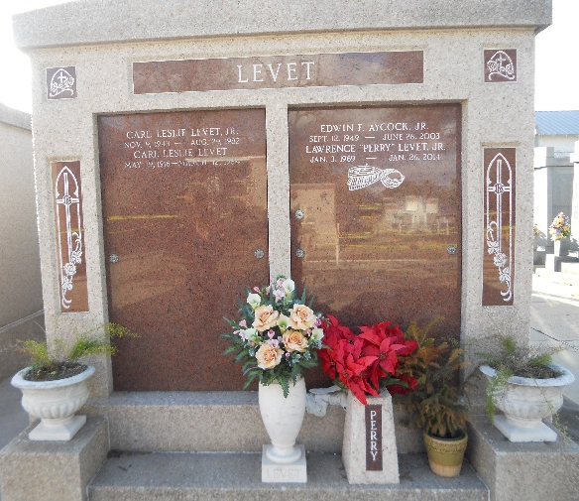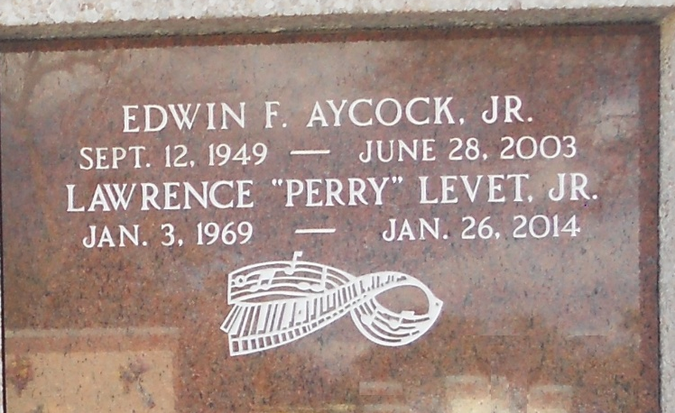
Photos by Team T-Lo

Lawrence (Perry) Levet Jr., died on Sunday January 26, 2014 after a year long battle with leukemia. Beloved father of Gabrielle Leslie, Jeanne Claire, and Madeleine Elise Levet. Son of Larry and JoAnn Madere Levet. Brother of Shelly Ernst, Kelly Curtis and Angelle Farrell. Grandson of Pearl Madere and the late Earl Madere and Myrtle Levet and the late Carl Leslie Levet. Also survived by numerous aunts, uncles, cousins, nieces and nephews. Former husband of Janel Jaubert Levet and devoted friend of Nicole Remondet.
Age 45. A native of Garyville/Reserve and a resident of Hammond. He was a graduate of St. Charles Catholic High School and Memphis State University and was Sales Manager of Volvo Rents.
Relatives and friends are invited to attend services. Visitation at St. Peter Catholic Church, Reserve, LA on Thursday January 30, 2014 from 10:00am to 1:30pm, followed by Mass at 2:00pm. Burial in St. Peter Cemetery.
Special thanks to Doctors and staff of St. Tammy Parish Hospital and Hospice for their care of Perry. In lieu of flowers masses preferred. Arrangements by Millet-Guidry Funeral Home, LaPlace, LA.
Advocate, The (Baton Rouge, Louisiana)
Tuesday, January 28, 2014
Contributed by Jane Edson

