Maria Victorine (Ory) Levet
October 8, 1879 – June 2, 1939

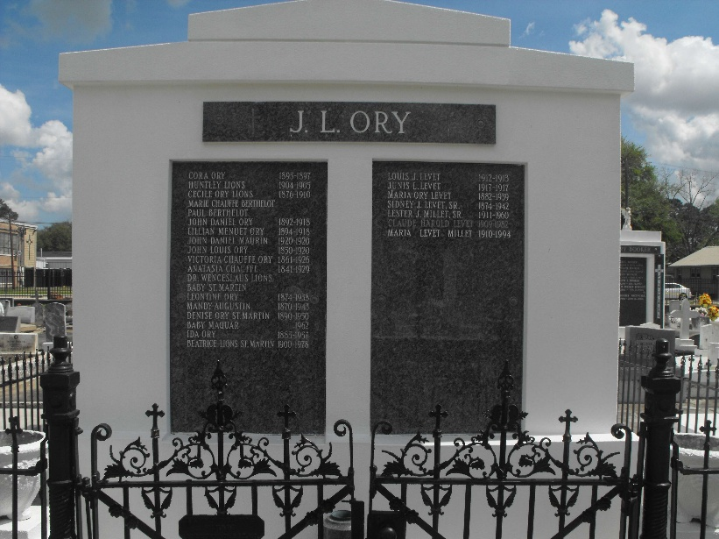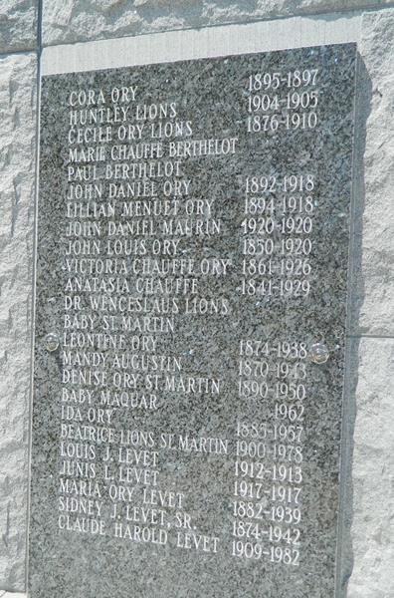
Photos by Mary Agnes Hammett

Mrs. Sidney Levet Passes Away

It is our painful duty to chronicle the death of Mrs. Sidney J. Levet, Sr., (nee Maria V. Ory) of Lions, this Parish. Deceased died at Hotel Dieu in New Orleans last Friday morning, June 2nd, at 4:55 o’clock surrounded by her loved ones.
She was a native and life-long resident of this parish and was held in the highest esteem by all who knew her.
Besides her grief-stricken husband, she leaves to mourn her departure two daughters, Mrs. Winnie Lodrigue of New Orleans, Mrs. Lester J. Millet of Garyville, three sons, Sidney, Jr., Claude H., and Leslie Levet. Several grandchildren also survive.
Funeral services were conducted at the St. Peter’s Catholic Church, at Reserve, La. this Saturday morning at 9 o’clock. Interment was in the family tomb in the St. Peter’s Cemetery in Reserve.
Le Meschacebe proffers its many sympathies to the bereaved and grief stricken ones at this dark moment of life.

Le Meschacebe, Lucy, Louisiana
Contributed by Sid Levet

