Myrtle (Perilloux) Levet
January 27, 1921 – July 18, 2017

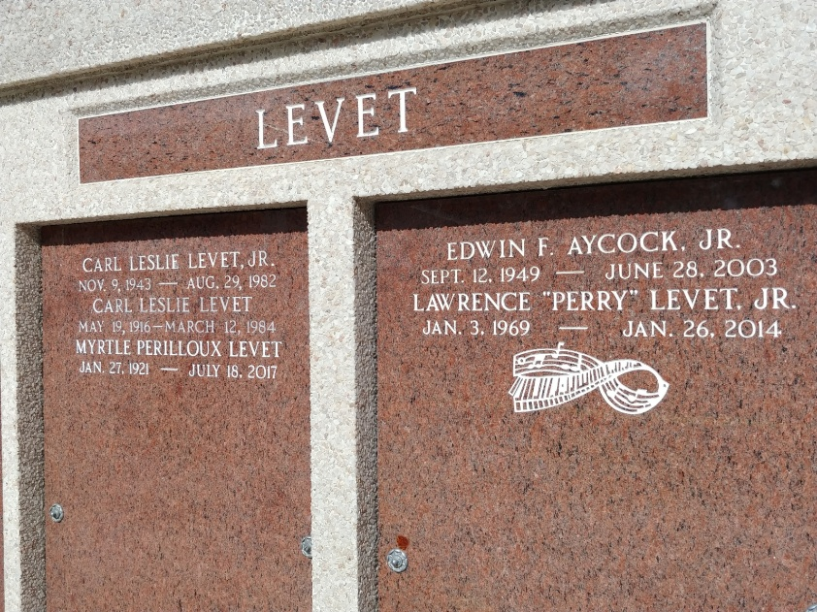
Photo by Team T-Lo

Myrtle Perilloux Levet, age 96, a resident of Lions, LA passed away peacefully on July 18, 2017. She was the daughter of the late Lawrence and Katherine Tamplain Perilloux.
Myrtle was a devoted mother to Lawrence "Larry" Levet (JoAnn), Emilie "Mimi" Blank, Yvette Dornier (Benny), Angelique "Angel" Aycock, Claude Levet (Zebee), and Jacques Levet (Yvette). She was a wonderful maw maw to Shelly Ernst, Kelly Curtis, Angelle Farrel, Margaret, Caroline and Billy Hogan, Matthew and Andrew Dornier, Martin Aycock and Jacques Levet, Jr. She was blessed with 21 great grandchildren: Gabrielle, Jeanne and Maddy Levet, Jordan, Chloe and Camryn Ernst, Leslie, Courtney and Christina Curtis, Ella, Amelia and Olivia Farrel, Kailyn and Lauren Accardo, Ashton and Gavin Kimble, Zachary Denham, Mason, Kate, Alex and Sammy Dornier, and great great grandmother to Bjorn Hickman.
There was always an open door to her home and everyone loved to go there to visit and see what was cooking. She was a very loving mom who enjoyed having her family near her. She is survived by her sister, Geraldine "Jerry" Luminais and preceded in death by a sister Gloria, who died at the age of 3, her late husband, Carl Leslie Levet, a son, Carl "Putsy" Levet, and her grandson, Lawrence "Perry" Levet. She was a member of the Catholic Daughters of the Americas for 65 years.
The family would like to thank Ollie Steele Burden Manor in Baton Rouge, for the wonderful care they have given her, and also to The Hospice of Baton Rouge, where she received care for her final weeks.
Visitation in her honor will be Saturday, July 22, 2017 at St. Peter's Catholic Church, 1550 Hwy 44, Reserve, LA from 9:00 a.m. to 11:00 a.m., followed by a mass of Christian Burial at 11:00 a.m. Interment will be in St. Peter's Cemetery. Arrangements by Millet-Guidry Funeral Home.

The Advocate, Baton Rouge, Louisiana
July 19 - 22, 2017

