Percy J. Levet
May 17, 1917 – January 16, 1992

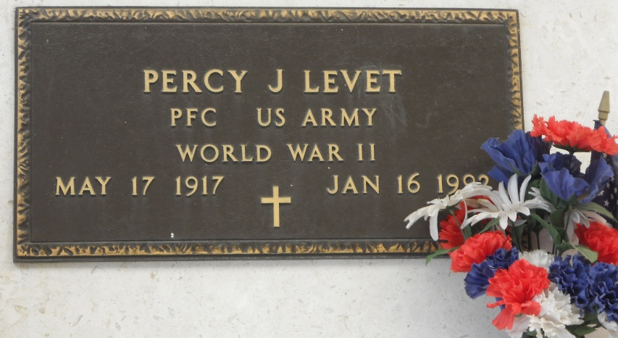
Photo by Team T-Lo

Percy J. Levet, on Thursday, January 16, 1992 at 3:30 p.m. Beloved husband of Ruth Montz Levet. Father of Loma Linda Levet Michel. Grandfather of Lei Lani and Lacie Lin Michel. Father-in-law of Floyd (Bosco) Michel Jr. Brother of Lemonce and Ernest Levet, Bonnie L. Weber, Gloria L. Vicknair and the late Thelma L. Stout and Aimee L. Jacob.
Son of the late Olive Millet Levet and John Levet. Age 74 years. A native and resident of Reserve.
Relatives and friends of the family, also employees of Avondale Shipyards, are invited to attend the funeral services at Millet-Guidry Funeral Home, 2808 West Airline Hwy, Reserve, LA on Saturday, January 18, 1992 followed by religious services at St Peter Catholic Church, Reserve, LA at 10 a.m. Interment Church Cemetery.

The Times-Picayune, New Orleans, Louisiana
January 17, 1992, p. B6

