Ruth (Montz) Levet
June 14, 1918 – July 29, 2009

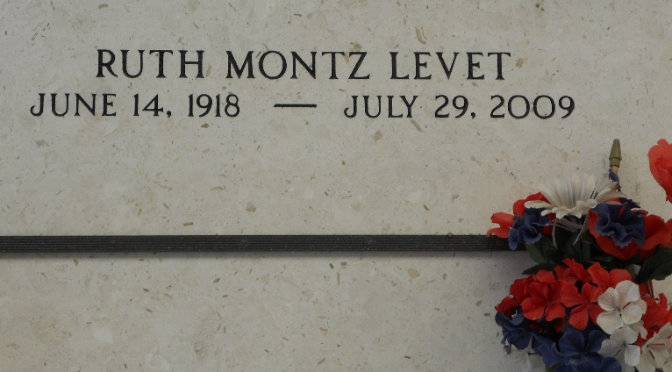
Photo by Team T-Lo

Ruth Montz Levet on Wednesday, July 29, 2009 at 7:30 am. Beloved wife of the late Percy Levet. Mother of Loma Linda Levet Michel and husband Floyd (Bosco) Michel, Jr. Grandmother of Lei Lani and Lacie Lin Michel. Sister of Edward (Za) Montz and the late Helmuth, Ruffin, Harry and Eddie Montz, Florence Vicknair, Ruby Roussel and Evelyn Graungard. Age 91. A native of Edgard and a resident of Reserve.
Relatives, friends and also Ladies Altar Society are invited to attend services. Visitation at St. Peter Catholic Church, Reserve, La. on Friday, July 31, 2009 from 9:00 am to 11:00 am. Followed by a Mass at 11:00 am. Burial in St. Peter Cemetery. Arrangements by Millet-Guidry Funeral Home, LaPlace, La.

The Times-Picayune, New Orleans, Louisiana
July 30, 2009

