Sidney Joseph Levet Sr.
March 31, 1874 – April 22, 1942

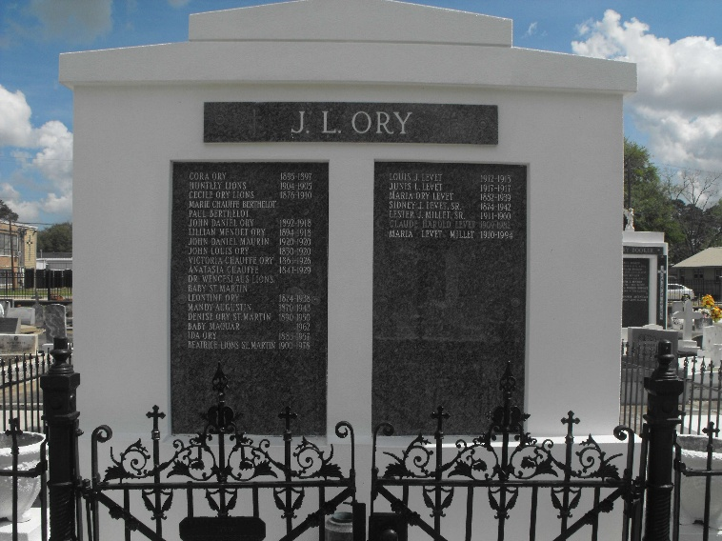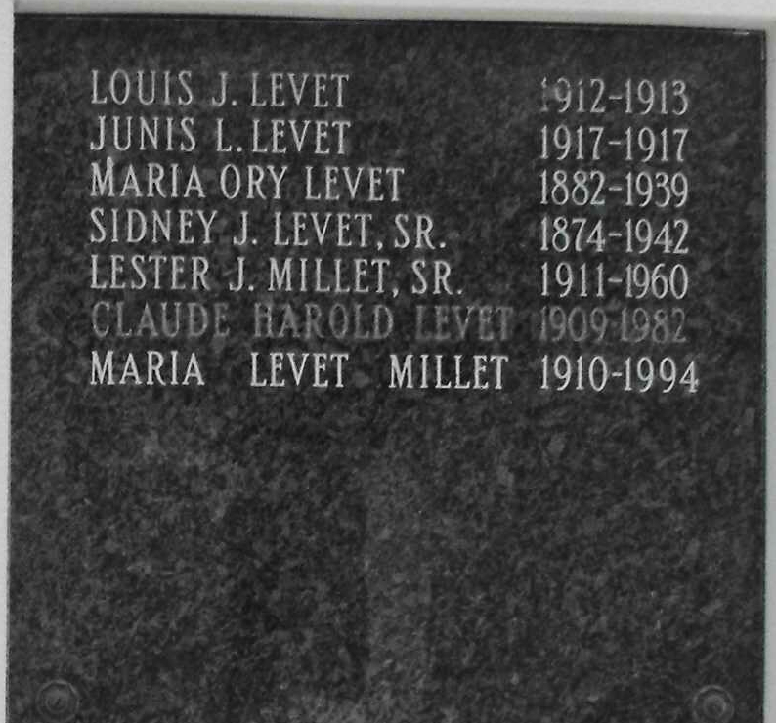
Photo by Mary Agnes Hammett

Sidney Levet Passes On After Heart Attack

The town of Lions, the Parish of St. John and the State of Louisiana has suffered an irreparable loss in the passing of Mr. Sidney J. Levet, Sr., one of the most useful and best loved citizens, whose sudden death occurred Wednesday morning at 1:30 o’clock, in his home on San Francisco Plantation, in the Sixth Ward of this parish.
His funeral which was attended by a large concourse of relatives, friends and acquaintances, including the colored men and women of the plantation, was held at St. Peter’s Catholic Church, at Reserve, Thursday morning at 9:30 o’clock requiem mass. The services were conducted by Msgr. J Eyraud, Rev. A. J. Lieux and Rev. John Grootens of St. Hubert’s Church of Garyville.
Mr. Levet was president of San Francisco Planting and manufacturing Co., of Lions. He was a man of fine principles, devoted to his family, for whom no sacrifice was too great. Endowed with a splendid personality and other rare characteristics, he had a wide circle of friends and acquaintances, and each of them his death comes as a shock and personal loss. His was a life founded on Christian principles and on righteousness, replete with kind, noble deeds, and in every relation he displayed those qualities that are honored among men and held up as worthy of in high regard and esteem, his memory will ever be green. He was a man of deep conviction and abiding principle, with the courage to abide by his convictions, often at great personal sacrifice, he leaves the stamp of his personality upon the citizenship of St. John Parish. Fran, firm and friendly, he bore himself with grace and dignity, his manner of meeting the problems of life was an inspiration to many.
Although Mr. Levet’s familiar figure will be seen no more among men, and his encouraging smile will no longer warm the hearts of his many friends, his life has not disappeared, for it is written in the hearts of men and will live for years to come.
Deceased who was 67 years old had married Miss Maria Ory, who preceded him to the grave some three years ago, is survived by two daughters, Mrs. Winnie Lodrigues of New Orleans, and Mrs. Lester Millet of Lions, three sons, Sidney Jr., Claude and Leslie, and several grandchildren.

Unknown newspaper clipping
Contributed by Sid Levet

