Drozin Loup
June 10, 1875 – November 17, 1943

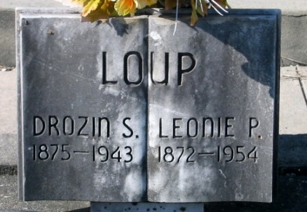
Photo by Bobby

Loup – At Hotel Dieu, New Orleans, on Wednesday, November 17, 1943, at 10: 35 o’clock p.m. Drozin S. Loup, husband of Leonie Poche, father of Ben Loup of Gramercy, La.; brother of Wilfred and Joseph Loup; aged 65 years; a resident of Convent, La.

Relatives and friends of the family are invited to attend the funeral, which will take place from Alexander’s funeral home, Lutcher, La., on Friday, November 19, 1943, at 3:30 o’clock p.m. Religious services at St. Peter’s church, Reserve, LA. Interment in St. Peter’s cemetery, Reserve, LA.

Times-Picayune, The (New Orleans, Louisiana)
Friday, November 19, 1943, p. 2

