Elmire (Haydel) Loup
September 11, 1920 – January 15, 2013

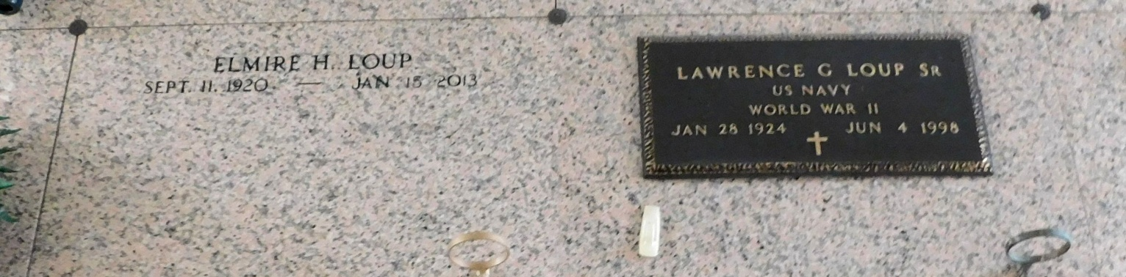
Photo by Mary Agnes Hammett

Elmire Haydel Loup, 92, passed away on Tuesday, Jan. 15, 2013.

She was the daughter of the late Oliver and Edna Haydel and the sister of Theresa Wine, the late Hamilton, George and Corrine Haydel. She was a native of Edgard and a resident of Reserve. She was the beloved wife of the late Lawrence Loup. She was the mother of Lawrence Jr. (Monica), Charles (Sandy), Randy (Mary) and Mark Loup (Cindy). She is also survived by five grandchildren and seven great-grandchildren.

Relatives and friends are invited to attend services. Visitation will take place at St. Peter Catholic Church, Reserve on Friday Jan. 18, 2013 from 8 a.m. to 10 a.m., followed by Mass at 10 a.m. Burial will follow in St. Peter Cemetery. Special thanks to Chateau St. James. Arrangements will be handled by Millet-Guidry Funeral Home in LaPlace.

L'Observateur, LaPlace, Louisiana
Thursday, January 17, 2013

