Lawrence Gerard Loup, Jr.
January 15, 1948 – March 8, 2017

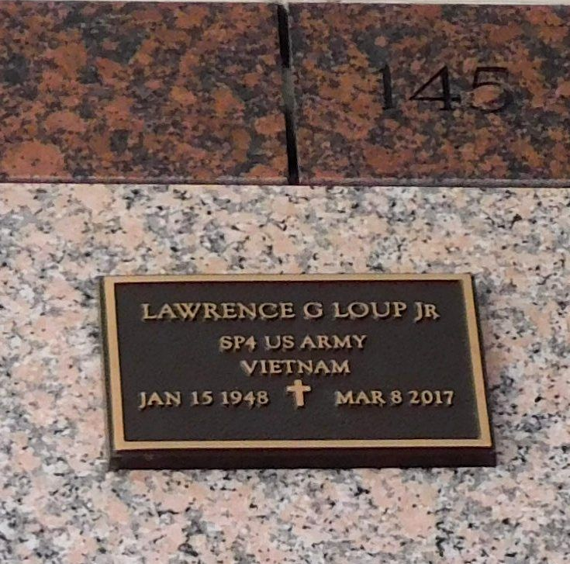
Photo by Mary Agnes Hammett

Lawrence G. Loup, Jr. passed away on Wednesday, March 8, 2017 at the age of 69. He was a native of New Orleans, LA and a resident of Reserve, LA. Beloved husband of the late Monica Raines Loup. Son of the late Elmire Haydel Loup and Lawrence Loup, Sr. Brother of Charles, Randy and Mark Loup. Also survived by many nieces, nephews and great-nieces and great-nephews.
Relatives and friends are invited to attend the Funeral Mass at St. Peter Catholic Church, 1550 Hwy 44, Reserve on Monday, March 13, 2017 at 11:00 a.m. Visitation at the church from 9:00 a.m. until 11:00 a.m. Interment in St. Peter Cemetery.

Millet-Guidry Funeral Home, LaPlace, Louisiana

