Agnes Marie (Loupe) Loupe
October 26, 1926 – December 16, 1986

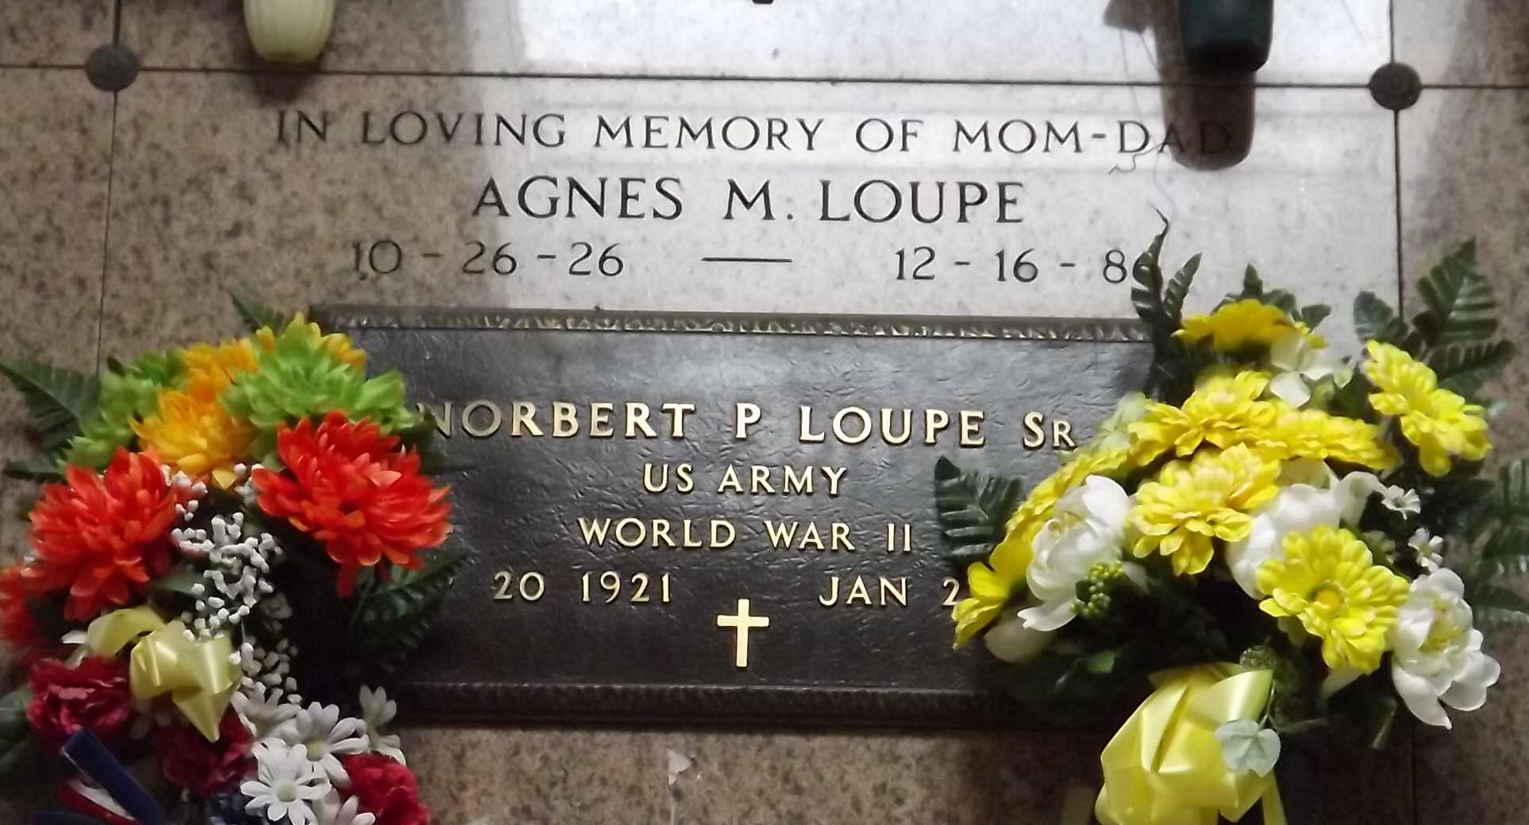
Photo by Mary Agnes Hammett

Agnes Loupe Loupe on Tuesday, December 16, 1986 at w:20 o’clock AM. Beloved wife of Norbert Loupe, Sr. Mother of Mrs. Murphy (Leana) Nicholas, Norbert, Jr., Barry, Howard, David, Lennard, Thomas and Dennis Loupe. Also survived by 20 grandchildren and 5 great-grandchildren. Age 60 years. A native of Gramercy, LA and a resident of Laplace for the past 20 years.
Relatives and friends of the family are invited to attend the Funeral Services from Millet Funeral Home, Reserve, LA, on Wednesday, December 17, 1986 at 10:30 o’clock AM followed by a Mass of Christian Burial at St. Peter Catholic Church. Interment in Church Cemetery, Reserve, LA Friends may call from 5 PM to 10 PM on Tuesday and from 8 AM until services on Wednesday.

The Times-Picayune, New Orleans, Louisiana
Wednesday, December 17, 1986, p. B-15

