Allen J. Loupe
July 27, 1932 – January 26, 2004

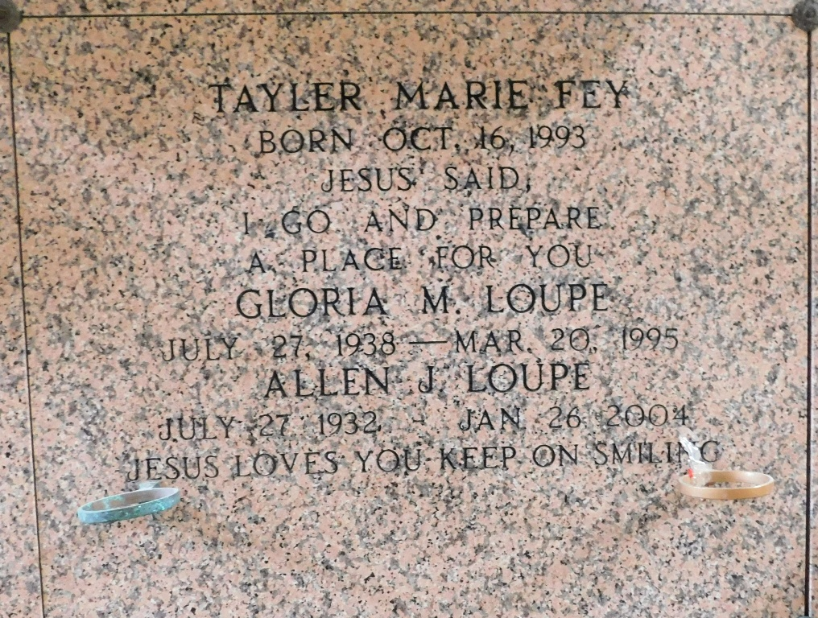
Photo by Mary Agnes Hammett

Allen J. "Billy'' Loupe, Sr. on Monday, January 26, 2004 at 9:45 AM.
Beloved husband of the late Gloria Vicknair Loupe. Father of Allen, Jr., Dwain and Lorne Loupe, Patricia Stall and Sandra Fey. Son of the late Joseph and Marie Waguespack Loupe. Brother of Gerard, Kermit, Sr., Ernest, Sr., Ralph "Big Shot'' and Donald Loupe, Sr. Also the late Eleanor Montz, Joseph, Jr. and Norbert Loupe, Sr. Also survived by 11 grandchildren, 5 great-grandchildren and 1 deceased grandchild. Age 71 years. A native of Reserve, LA and a resident of Laplace, LA for the past 22 years.
Relatives and friends of the family are invited to attend services. Visitation at Reserve Christian Church, 3556 West Airline, Reserve on Wednesday, January 28, 2004 from 5-9 PM and on Thursday from 8-10AM. Followed by religious services at the church at 10AM. Burial in St. Peter Cemetery, Reserve. Arrangements by MILLET GUIDRY FUNERAL HOME, Laplace, LA.

The Times-Picayune, New Orleans, Louisiana
Jan. 27, 2004

