Alvin Paul Loupe, Sr.
April 28, 1930 – May 11, 2023

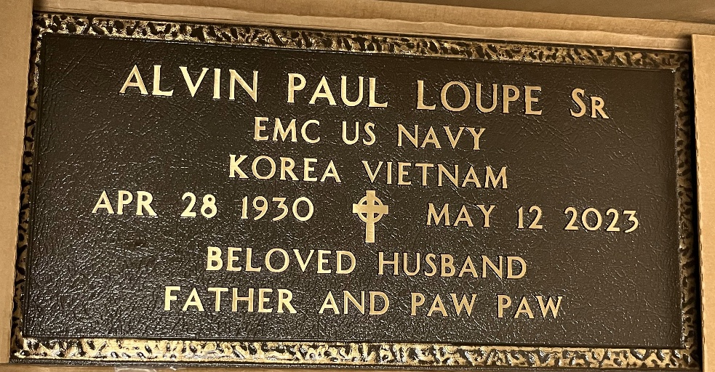
Photo by Team T-Lo

Alvin Paul Loupe “Sarge” left this earth on May 12, 2023 at the age of 93. He was a native of Gramercy, LA and a resident of Garyville, LA. He was the last surviving child of the late George Sr. and Palmyre Badeaux Loupe.
At age 18, he joined the United States Navy and retired after 20 years serving his country as an EMC. He served on FIVE vessels - the Roanoke, Minos, Haas, Randolph, Greenwich Bay, Escape. He was on active duty during the Korean War. He also was the recipient of the Navy’s Marine Medal for Heroism aboard the USS Escape. He often had to forgo the raising of his family while at sea for months at a time.
After retiring from the Navy on July 3, 1967, he worked at Avondale Shipyards and Marathon Petroleum Company as Electrical Supervisor with both companies. He retired at age 70 in 2002 to be at peace riding his lawn mower while cutting everyone’s grass.
Alvin was the beloved husband of the late Gloria Torres since August 30, 1952, before her passing in 2017. He often referred to Gloria as his “Sunshine”. He was also predeceased by his parents and his two siblings: (Baby) Joseph Loupe and Olive Loupe Deroche.
Father of Barbara Oncale (the late Mickey), Peggy (Paul) Forsyth, Paul Loupe, Janice (Ted) Oncale and George Loupe. He is also survived by 16 grandchildren, 23 great-grandchildren and many nieces and nephews. Godfather to Nolan Deroche, Jr. and Debbie Mensay.
He was a member of American Legion, Fleet Reserve Assoc., and VFW.
He never failed to visit his loving wife daily, talking to her in the hallowed paths of the peaceful cemetery.
Alvin Paul Loupe belonged to the Greatest Generation, who walk their talk both alone and with others. His favorite saying was “I’m so happy”.
Pallbearers carrying their “PawPaw” to his final resting place are his grandsons Lee, Lance and Pete Oncale, Jeremy and George Loupe III, and Connor Walsh. Honorary pallbearers are Pete Torres and Nick Dauzat and godchild Nolan Deroche.
Relatives and friends are invited to attend the Funeral on Monday, May 15, 2023 at St. Hubert Catholic Church, 176 Anthony F Monica St., Garyville. Visitation will be held at the church from 9:00 a.m. to 11:00 a.m. The Funeral Service will immediately follow at 11:00 a.m. Interment in St. Peter Cemetery with full Military Honors with his beloved “Sunshine”.
Special Thanks to the staff at Francois Bend Assisted Living in Gonzales for their compassionate care over the last nine months. He addressed everyone at the home as “Sha”.

Millet-Guidry Funeral Home, LaPlace, Louisiana

