Carol (Lemoine) Loupe
August 7, 1938 – September 15, 1972

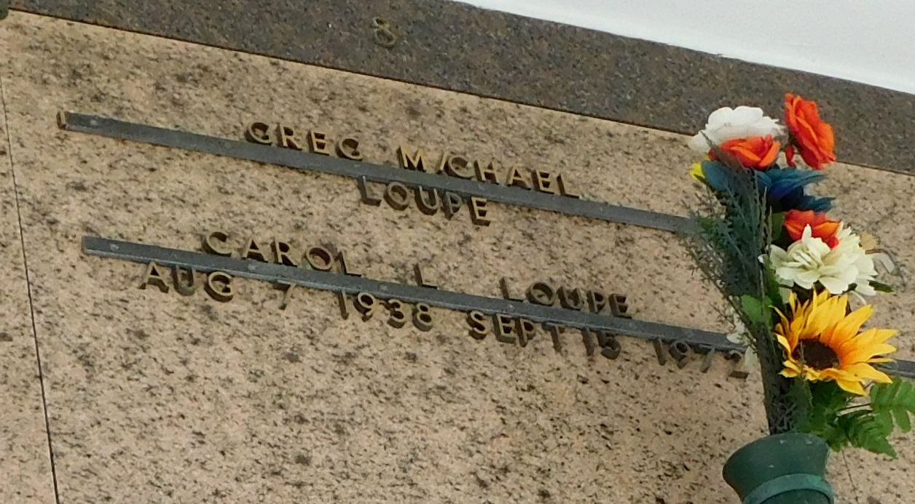
Photo by Mary Agnes Hammett

Carol ‘Cookie’ Lemoine Loupe, of Reserve, Louisiana, on Friday Sept. 15, 1972 at 4:40 o’clock a.m.; beloved daughter of Mr. and Mrs. Herman Lemoine of Reserve, Louisiana; age 34 years; a native of Reserve, Louisiana.

Relatives and friends of the family are invited to attend the funeral. Services from millet Funeral Home, Reserve, Louisiana, on Saturday, September 16, 1972, at 10 o’clock a.m.; followed by religious services at St. Peter Church, Reserve, Louisiana. Interment St. Peter mausoleum. Friends may call from 8 a.m. to services on Saturday.

The Times-Picayune, New Orleans, Louisiana
Saturday, September 16, 1972, p. 20

