Danny J. Loupe
January 31, 1959 – April 20, 2015

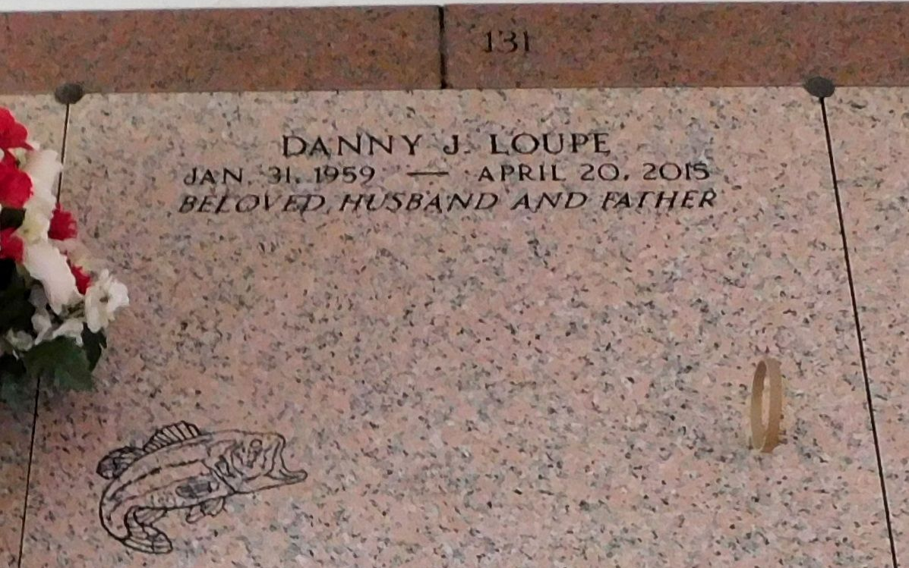
Photo by Mary Agnes Hammett

Danny J. Loupe, 56, was born Jan. 31, 1959, and died on April 20, 2015. He was a native and resident of Reserve.
He is survived by his wife, Debra Jacob Loupe; daughters Jennifer Brady and husband James, and Jessica Loupe. He is also survived by brothers and sisters Ernest Loupe Jr., Kent Loupe, Gayle Courtney and Janie Woodson. He leaves behind his beloved pets Snowie and Sassy.
He was preceded in death by parents Ernest Loupe Sr. and Vivian Cyrus Loupe; brother Charles Monroe and sister Linda Edler. His favorite things to do were fishing, hunting and woodworking.
Visitation will be on Friday, April 24 from 9 until 11 a.m. at St. Peter Catholic Church in Reserve, followed by a Mass of Christian Burial at 11 a.m. Interment will be in the church cemetery. Rose Lynn Funeral Services in Lutcher is in charge of the arrangements.

L’Observateur, LaPlace, Louisiana
April 22, 2015

