Donald Raymond Loupe Sr.
August 4, 1937 – July 10, 2017

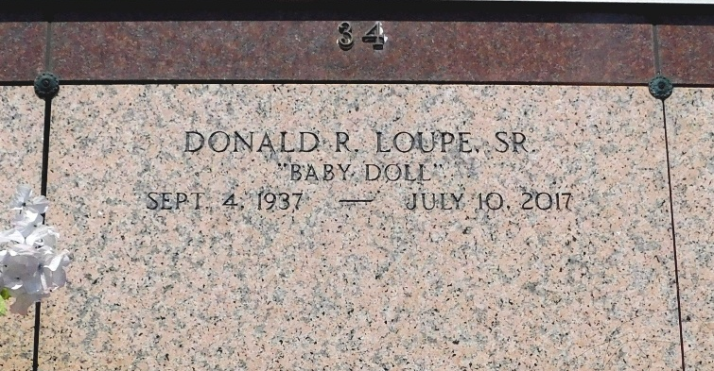
Photo by Mary Agnes Hammett

Donald Raymond Loupe, Sr. passed away on Monday, July 10, 2017 at the age of 79. He was a native and lifelong resident of Reserve, LA. He retired from Freeport McMoRan and was a 4th degree Knight of the Knights of Columbus Council No. 2436 Msgr. Jean Eyraud of Reserve. Donald was a parishioner and eucharistic minister for St. Peter Catholic Church.
Beloved husband of 59 years to Marian Maus Loupe. Loving father of Donald Loupe, Jr., Chris Loupe (Wanda), Troy Loupe (Terrilyn), Russell Loupe and the late Rhonda Loupe Webre. Grandfather of Zachary Loupe, Chelsea Loupe, Riley Loupe, Megan Oubre, Brienna Oubre, Walter Barado, III (Desiree) and Justin Loupe. Great grandfather of Kinley Ray Barado.
Son of the late Joseph Walter Loupe, Sr. and Marie Eleanor Waguespack.
Brother of Gerard Loupe, Ralph Loupe (Mary), and the late Kermit Loupe (Leona), Jospeh Loupe, Norbert Loupe, Marie Montz, Ernest Loupe and Allen Loupe. Brother-in-law of the late Willie Maus (Deanna). Also survived by many nieces and nephews.
Relatives and friends are invited to attend the Funeral Mass at St. Peter Catholic Church, 1550 Hwy 44, Reserve, LA on Friday, July 14, 2017 at 11:00 a.m. Visitation will begin in church at 9:00 a.m. Interment in St. Peter Cemetery. Arrangements by Millet-Guidry Funeral Home.

The New Orleans Advocate, Louisiana
Jul. 11 to Jul. 14, 2017

