Gloria Catherine (Torres) Loupe
September 20, 1932 – April 6, 2017

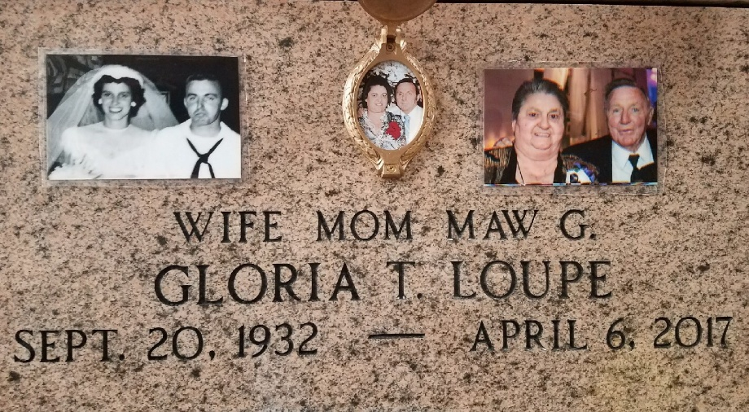
Photo by Team T-Lo

Gloria Torres Loupe left this earth on Thursday, April 6, 2017 at the age of 84. She was a native of New Orleans, LA and a resident of Garyville, LA.
Beloved wife of Alvin P. Loupe Sr. Mother of Baba Oncale (the late Mickey), Peggy Forsyth (Paul), Paul Loupe, Janice Oncale (Ted) and George Loupe. Daughter of the late Myrtle Rome and Clarence Torres. Sister of Mary Ann Marse, Lawrence J. Torres, Lois Mae James and the late Warren Sr., CJ, Shirley, Leonard and Stuart Torres and Elaine Bergeron. Also survived by 16 grandchildren, 19 great-grandchildren and many nieces and nephews.
Relatives and friends are invited to attend the Funeral. Visitation at Millet-Guidry Funeral Home, 2806 W. Airline Hwy, Reserve on Sunday, April 9, 2017 from 5:00 p.m. to 9:00 p.m. and on Monday April 10, 2017 at St. Hubert Catholic Church, 176 Anthony Monica St., Garyville from 9:00 a.m. to 11:00 a.m. The Funeral Mass will immediately follow at 11:00 a.m. Interment in St. Peter Cemetery.

Millet-Guidry Funeral Home, LaPlace, Louisiana

